- Itinerary
- Daily glimpses
- Expanded Itinerary

Israel Trip Nov. 2014 -822 and tour
NOTE: Itinerary subject to changes.
- Arrive in Israel Nov.6, 3:15 pm

- Netanya Nov.6/7/8
        - – 6- check in/ supper/bed :o)
        - /7th -beach – mall etc / free day relax
        - 8th - Caesarea

- Jerusalem Nov. 9/10/11/12/13/14
        - 9th Old City /western wall?
        - 10th– Israel Museum // evening 822 Gathering/
        - 11th -13th Gathering/
        - 14th Hezekiah’s tunnel, / Garden tomb: 2 pm appointment

- Neve Zohar Nov. 15/16 -
        - 15th - Engedi, [hike] /Massada [tram up] .. Dead Sea
        - 16th – Boskey’s / Abraham’s well … visit the ruins there, and perhaps go to the desert if time permits

- Tiberius Nov. 17/18/19/20
        - 17th travel with stops to Tiberius./ Tel Maresha caves …
        - 18th – morning relaxing at the Sea of Galilee/ Evening: visit HOPE Nazareth/ Arab Pastors@ Golden Crown?
        - 19th - boat ride on the Sea of Galilee/ Capernaum/ Mount of Beatitudes/ .[join M&W] [evening: Arab Pastor. Nazareth?]
        - 20th- [join Michael/Wanda] – Megiddo / Kehilat HaCarmel Worship Centre Mount Carmel… [possible evening meeting with an Arab pastor in Nazareth]
- Tel Aviv Nov.21
        - 21st – check out > >To Tel Aviv / hang out- beach/supper
        - 22nd … depart early morning 22nd need to be at airport by 2 am!

# 2 - Friday Nov. 7/14
We had a very nice relaxing day today… some were able to sleep in a little bit… trying to get over the jet lag with the 10 hour time change :o). I woke up at 4:30 and couldn’t go back to sleep so I’m ready for bed and it’s only 6 pm!
We realized after last night’s trek from the airport to Netanya that these little vans we rented just are not quite big enough to do the job the back seat is only big enough for a newborn and we don’t have quite enough room for luggage sooo I phoned around and found someone to talk to from the rental company and they tracked down a 9 passenger van for us so PTL we now can manage our transportation much better.
- Here is a picture from our Balcony at the Blue Weiss hotel in Netanya.
- 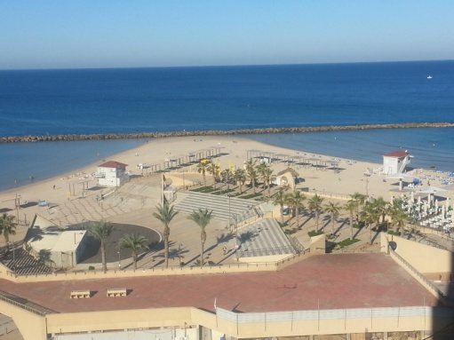
..========
Last night Beth woke up and saw a vision of our team gathered in the lobby of our hotel only instead of being ‘people’ we all looked like bags of gold coins…like the old pictures of a leather bag with drawstrings at the top. We were opened at the top and you could see the gold inside. We all appeared to be looking up waiting for instructions. She heard the words ‘divine exchange’ and began to ask the Lord what it meant. Two things came to mind. One was Honour. To walk in honour with each other, appreciating and recognizing the gift inside and calling it forth in each other and treating others around us with the same honour. The second thing was a key Steward gave at the table in conversation the night before: the verse from John 6:29
The Lord said “Your work is to believe. At this time we need to release hope and faith into the land and into the people. So spread your gold extravagantly everywhere! Believe Me. Expect Me. Pour Me out everywhere. It’s not what you’re doing, it’s who you are. (In Him we live and move and have our being’ It’s part of why it was fun and rich and deep between people all day, at the beach, shopping, at meals, whatever) Give this treasure out and I will continually fill you back up. Deposit and I will deposit in You what I want you to take back with you, to become part of you.’ Peter R reminded us a few times that as we enjoyed each other and the Lord wherever we went we would be releasing the Presence and accomplishing things in the spirit, sometimes without even knowing the full extent of what the Lord is doing.
David P said he always wanted to be a philanthropist [a very rich person who goes around giving huge amounts of money to worthy causes] He realized that he was never going to be a billionaire but then he realized that since we are in Christ we have even more that … we have all things in Christ and it is like we are sent on an assignment here in Israel and the Lord has given us billions of dollars and said go and spend it in Israel!

- So Lord we say that we are Yours - have Your way in us, we ask that you accomplish all that you intend for this time here in Israel, that everything You want released will be released.

Tomorrow we are off to Caesarea…

8-11-14
Today was our Acts 10 day … :o) We went to Caesarea or as their road sing said Qessariya or Kaesarea … sometimes there English rendition of a word is the phonetic spelling hence the funny English names. Makes for some interesting adventures when you miss a turn because you didn’t recognize the name of the place!
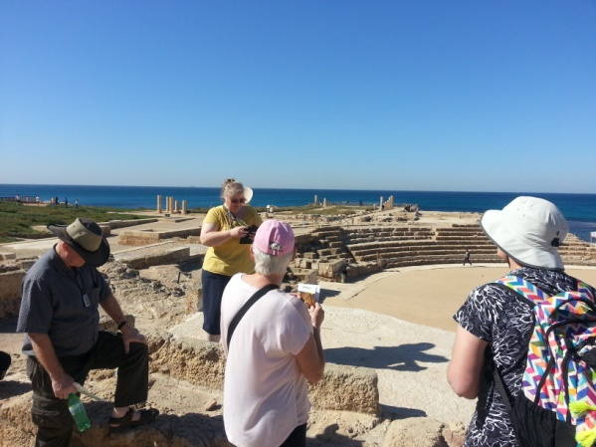
Linda was sharing with us the story from Acts chps 21-25 … the apostle Paul was held here by Herod for two years.. probably directly behind where Linda is standing close to the edge of the water, right there is the remains of Herod’s palace and Paul was likely held right in that area. He was on trial for his faith and when he took his stand against his accusers and ended up appealing to Caesar … so that meant he had to go to Rome! If you read back earlier in the story the lord told Paul that now that he had testified in Jerusalem he would also have to testify in Rome … seeing this place and hearing these stories gives us a better ‘picture’ of what happened.. so good!!
Here are a few more pics from Caesarea:
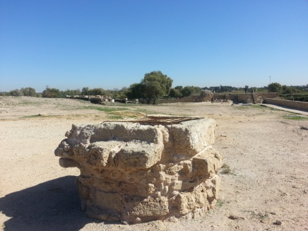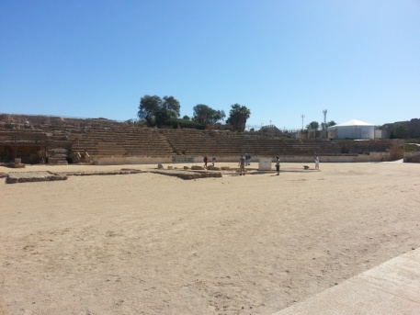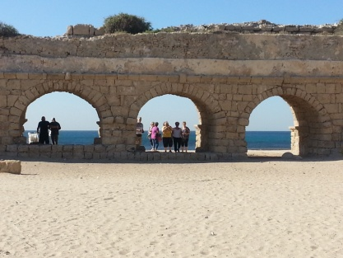
Picture of a well … probably 40 ft deep // chariot races – gladiators // ‘Herods’ aqueduct 13 miles long!
- Tomorrow we are off to Jerusalem … we will leave Netanya a 8:30 stop at our hotel in Jerusalem then go to the Old City and hopefully the Wailing Wall [Western Wall]
Thank you for standing together …. Send any words or insights you get to pziemer57@gmail.com

9-11-14
We made it to Jerusalem today, got here about 11:30.. we parked our vehicles at the hotel and got onto the Lite rail system and went down to a stop near the Old City intending to go into the Old City. We were about 5 minutes walk away from there and got a phone call from Stew telling us that their host’s Merve and Merla Watson [bed and breakfast] had just received a phone call from the government with a dire warning to not let any foreigners go into the old City as there was an upheaval there … so we felt our response was to obey the directive of the government … no one felt fearful or unsafe at all at any time we simply believe the lord is directing our path and we are happy to follow Him! The enemy wants to intimidate but I can honestly say it is like a lone mosquito buzzing around trying to irritate but is not even close to successful :o). We have been experiencing a constant high level of the close Presence of the Lord everywhere we go and are confident and secure in Him … He has called all of us… those here and those at home and it is the best place to be …. Right in the center of His will!
This evening a few of us were at a pre-gathering meeting along with maybe 500 others from the nations:
… At the meeting The Lord was setting the tone it seemed like. We spent the first 15 or 20 minutes worshipping and singing without the worship team. David was encouraging us to not rely on them but to enter in and the team would join in if they felt a release to. Lots of tongues and tribes and nations. The worship team did play after that. We moved into intercession for a lonnnng time. THERE'S NO MORE TIME!!NOW IS THE TIME. (Joan has a cool confirmation about the synchronized time. They were driving today and got a bit lost and stopped in the ICC parking lot where the gathering is held. She looked at the time and it was 11:11 here and 1:11am in Canada. 7 ones in a row. The number of completion!!)
The last song [spontaneous] that we sang for a long time was He will have His inheritance… we declared it over and over in many languages with the dance team prophetically declaring with us.
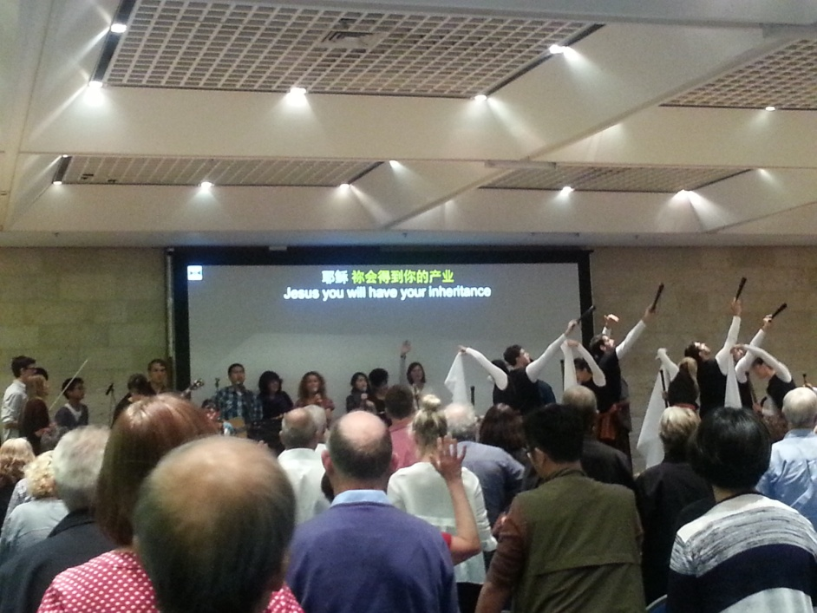
Then David D got up and encouraged us that The Lord is taking His place. It is not 'another gathering'. The Lord has called us here for a purpose. He wanted to say to everyone especially first timers that might think this is normal. He said he has never started a gathering this way, without the worship team etc but felt The Lord say to do it. He was encouraging us to submit our minds under the spirit. If our mind doesn't catch it don't worry. Let your spirit lead. He will bring revelation to our minds too. But He's setting order and He is displaying His manifold wisdom to the powers and principalities. The whole night was focused on Him. I'm sure He said more but my brain is tired. And I want to encourage you whether you are at a pre-gathering meeting or not ( some of you are here in the spirit only and not in the physical!) to allow The Lord to set the tone for it wherever we are. Father we lay down our preconceived ideas and agendas about this time and ask for You to lead us. Help us to keep our eyes right on You. Thank you for knitting the nations together. Jesus You will have Your inheritance!
I really love you all. We have a BIG family:) bziph…
At the very end David asked all of us to pray over the night that the Lord would have all that He desires during this Gathering…
… blessings to all / pzie

10.11.14
Today Beth and I went to the leadership pre meeting gathering in the morning and the others went to the Old City.. In the meeting there a an awesome time of worship/ powerful repentance between the Jews and the Arabs … very deep and powerful…
…we are meeting up with so many friends from all around the world! One big family :o)
In the Old City the others went in through the Jaffa Gate … looking and shopping and wound their way over to the Wailing Wall.. spent some time there praying and soaking up the atmosphere. Beth and I met them at the Wailing Wall then we went up to Jewish Quarter and had some lunch… sure seems like the tastes extra good for some reason :o)
Here a few pics from the old city… one from the Gathering

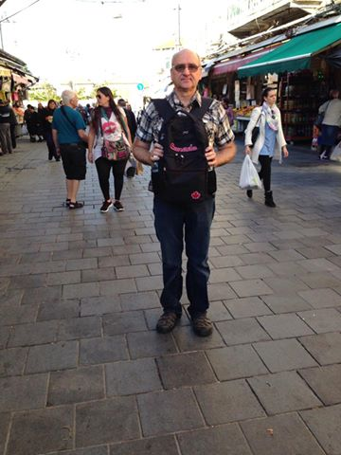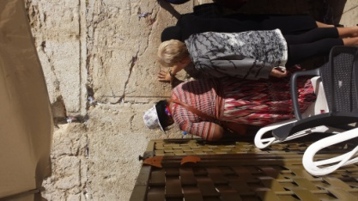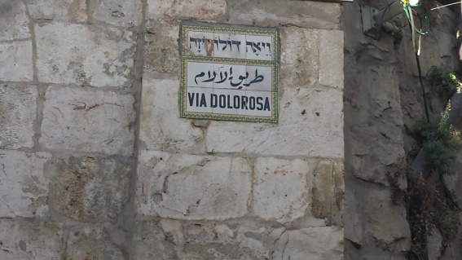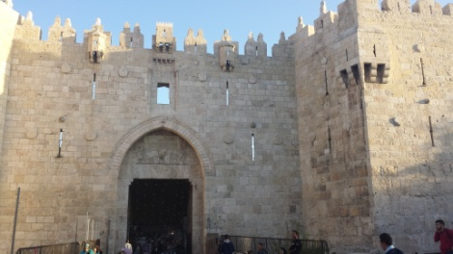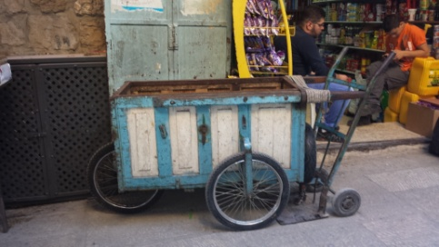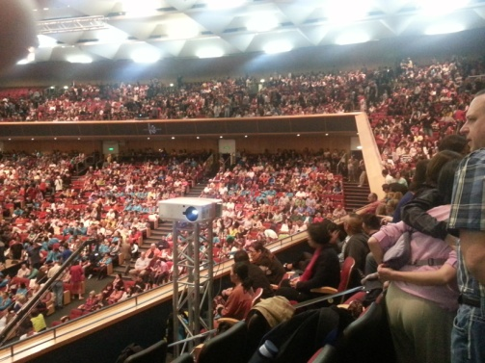
11/ 15, 16, 17 / 2014
Hezekiah’s Tunnel /Garden tomb /En Gedi / Massada/ Dead Sea/ Tel Maresha Caves and on to Tiberius
We are having the most amazing time! It really makes one read the bible differently when you are standing in the place that the story happened!!
- The tunnel that Hezekiah built is an underground water duct, it is 100’ underground and takes at least 30 minutes to walk through at a steady pace … it is an amazing engineering feat
Heze’s Tunnel: Read 1 Kings 18/19/20 for the story of Hezekiah
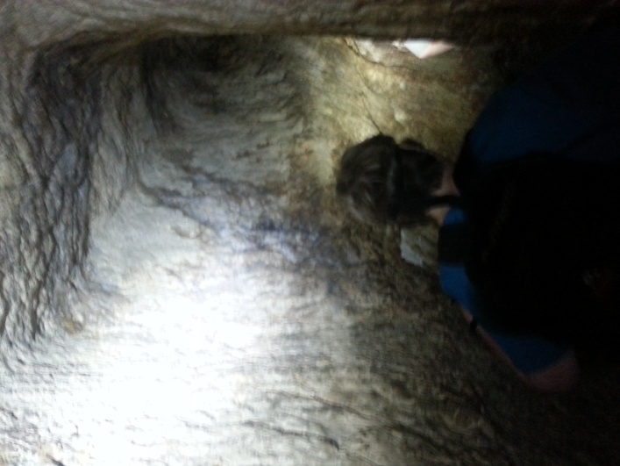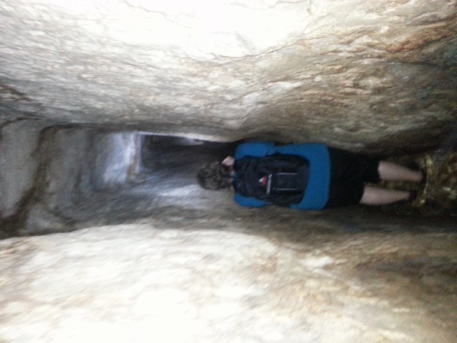
En Gedi: King David was in this area for many years avoiding King Saul … also the army that was coming to attack Jehoshaphat .. Moab and Ammon came around the dead sea with a very large army and were as far as En Gedi when Jehoshaphat heard they were coming… [2 Chron.20]
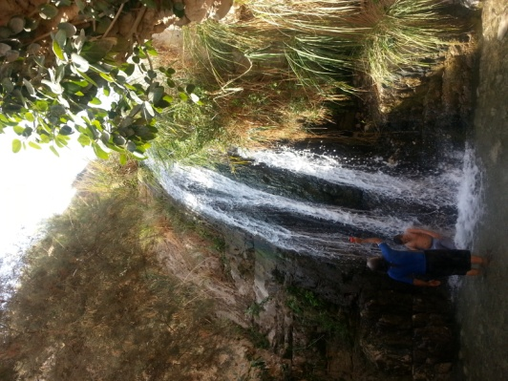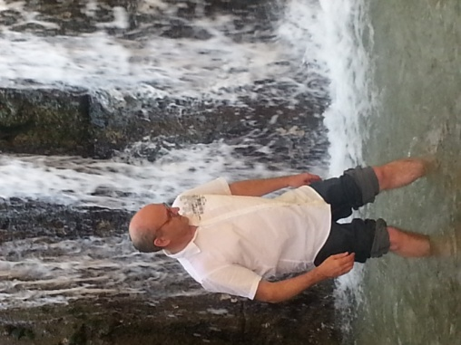

Massada
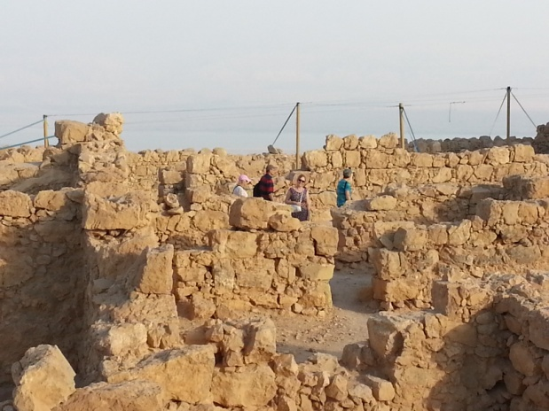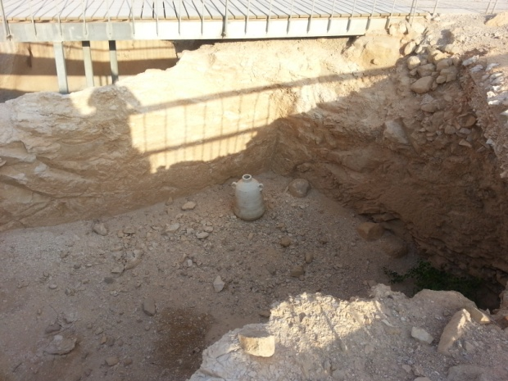
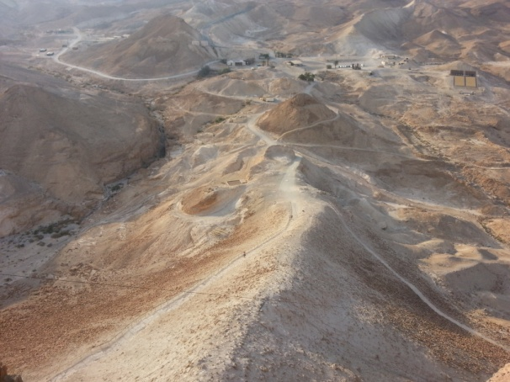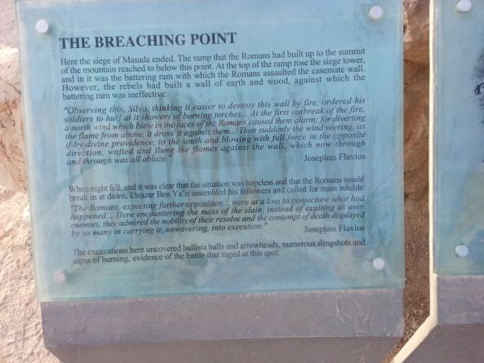

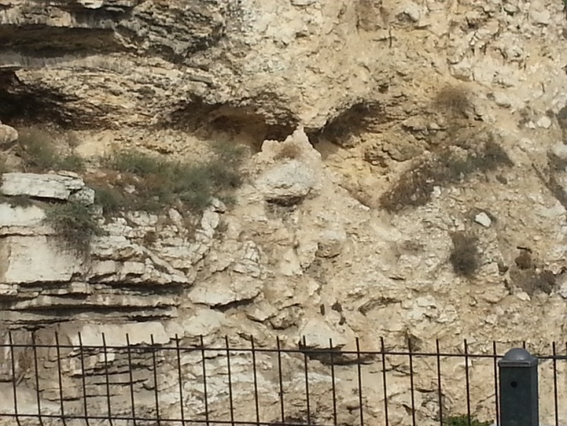 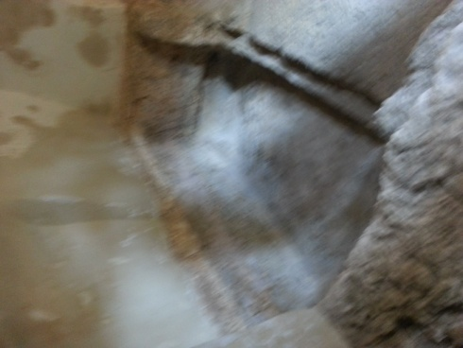tomb
place of the Scull – Golgotha
# 6/7 - 11.11.14 and 12.11.14

Enjoy the web streaming and archives of the 822 Gathering ….
Go to 822call.org and follow the links to live web stream or archives.

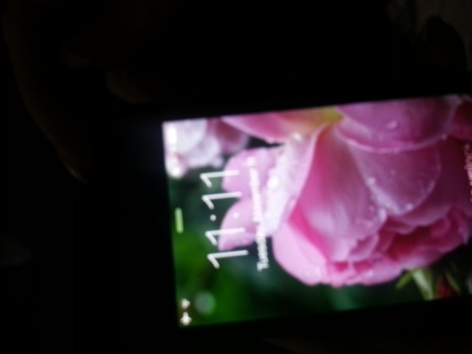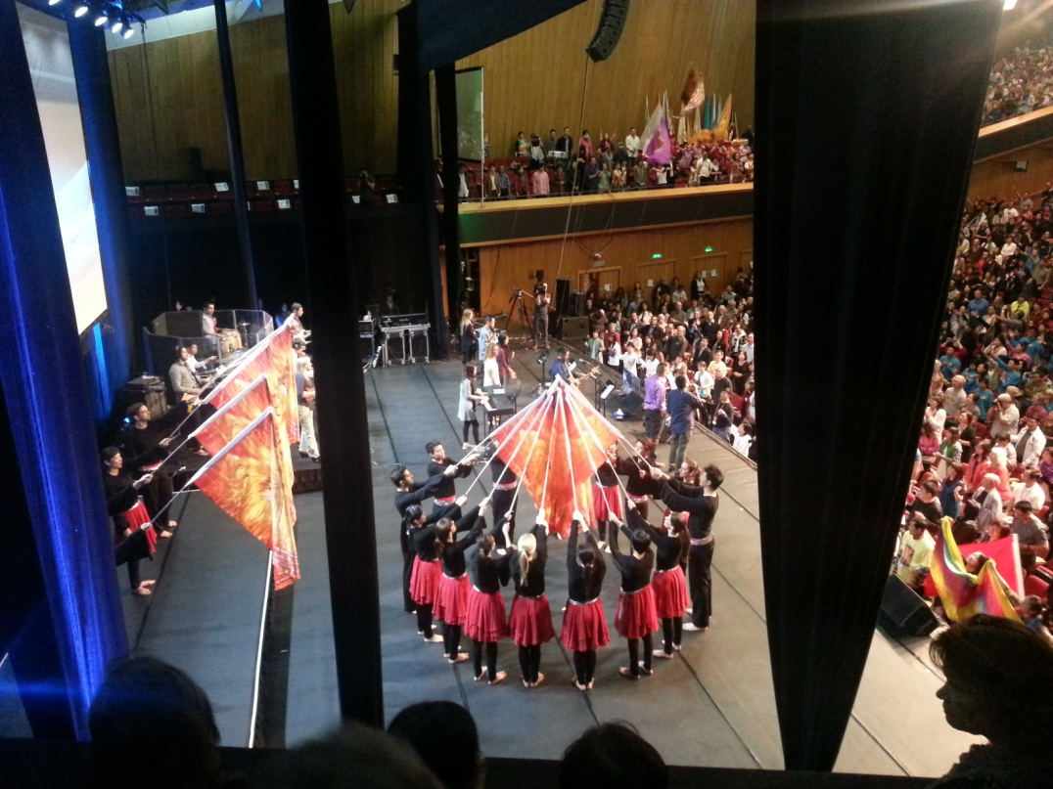

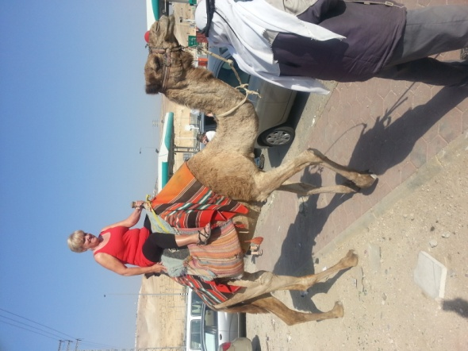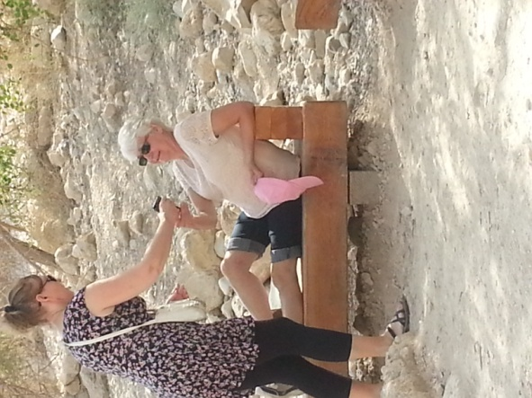
Camel ride! Feeding grapes to the queen
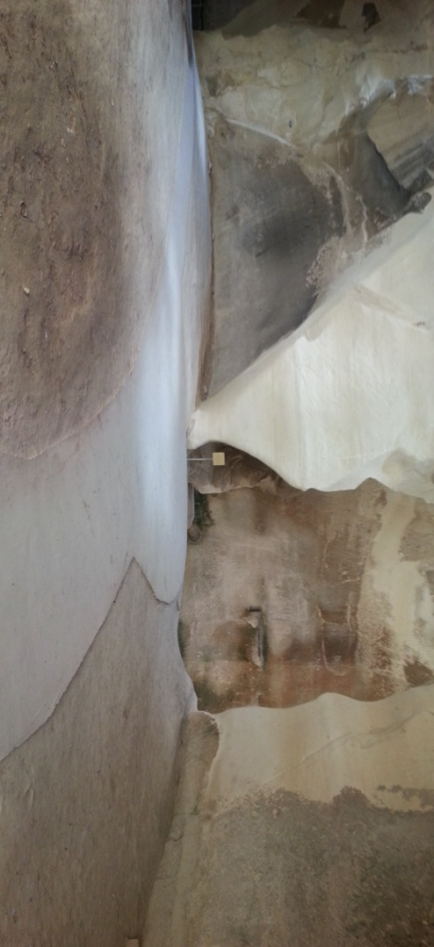
11.18/19
We had a relaxing day On the 18th .. then we went to Nazareth in the late afternoon. We met Michael Pierce and his group for supper at their hotel in Nazareth [Golden Crown] Then we had a meeting with Rania and 4 of her young staff from House of Prayer and Exploits and 6 Arabic pastors/ wives and 1 messianic pastor!! We had an amazing time together … sang a few worship songs and then milled around visiting and connecting with one another [about 60/70 people there] then Arabic pastors all shared a bit about themselves then Rania and her young people shared then the messianic pastor shared s heart … we did a few prophetic acts and prayed together … we also gave an offering to each pastor there and also to H.O.P.E [house of prayer and exploits] … here are a few pics.

Washing their feet:
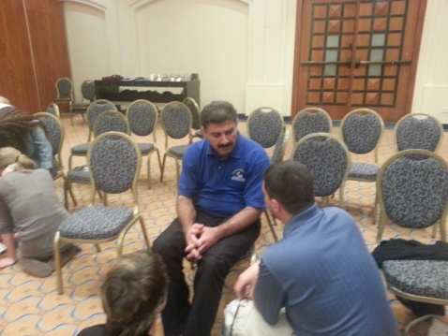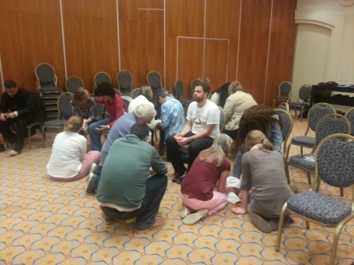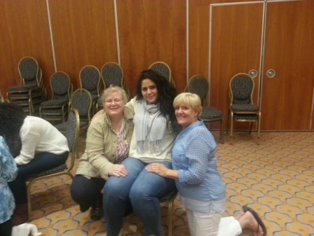

Canada and Israel:
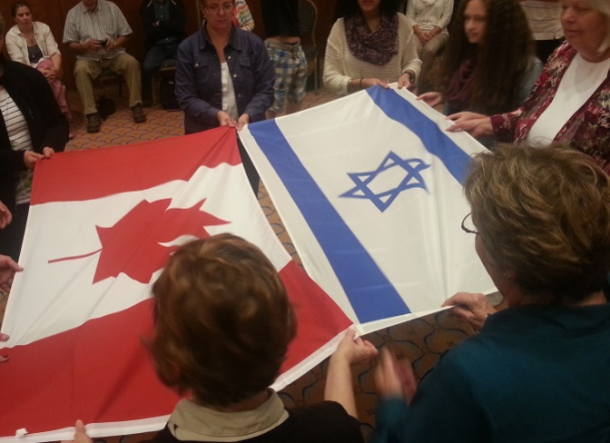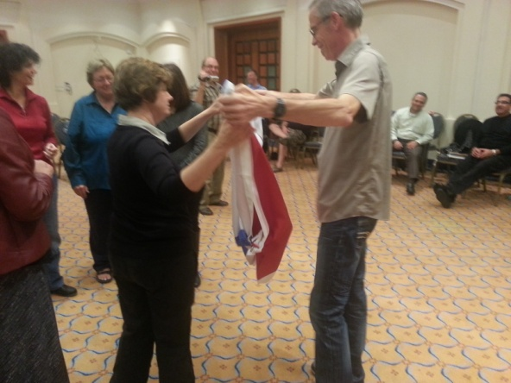
We were so blessed to meet with the believers in Nazareth … it is so important that we also pray for the Arab believers in the land.

19th … we did a drive all the way around the sea of Galilee which took about an hour then we meet with Michael and Wanda’s groups for lunch at Tanoreen Restaurant for St. Peter’s fish … yes the whole fish including the head :o).. then on to the boat ride on the sea of Galilee … we had a special treat there because our friends Michael and Florin Gertsman who live in Israel came along on the boat ride with us!! So much fun together with our global family :o)
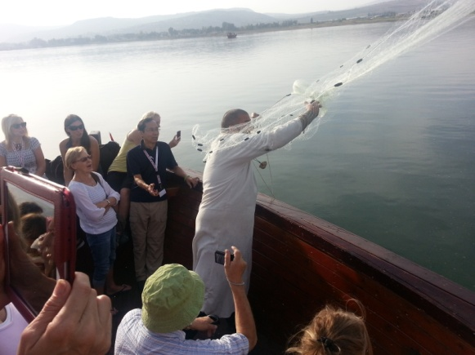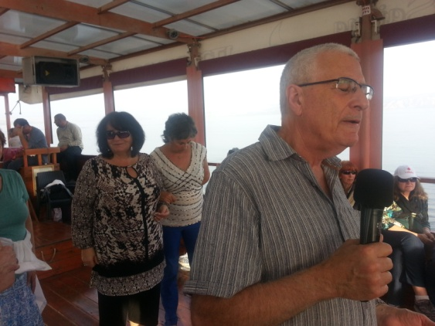
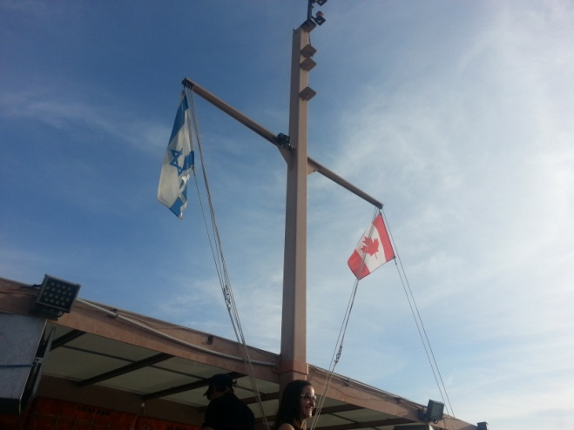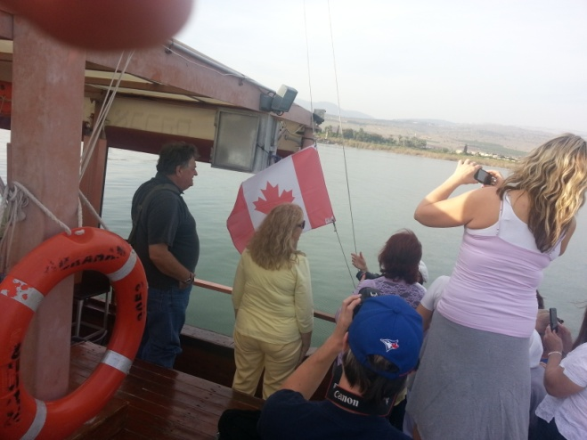
Then up to the Mount of Beatitudes…
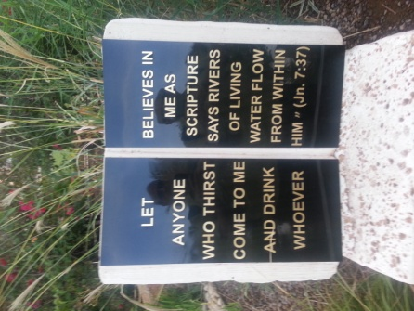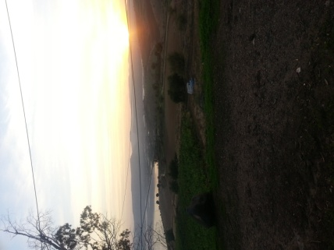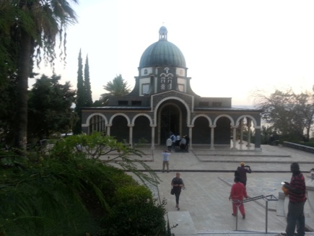
Yes we are having a wonderful time walking /driving and praying around the land here … meeting people visiting and fellowshipping … we are greatly blessed and so thankful for all of your prayers!

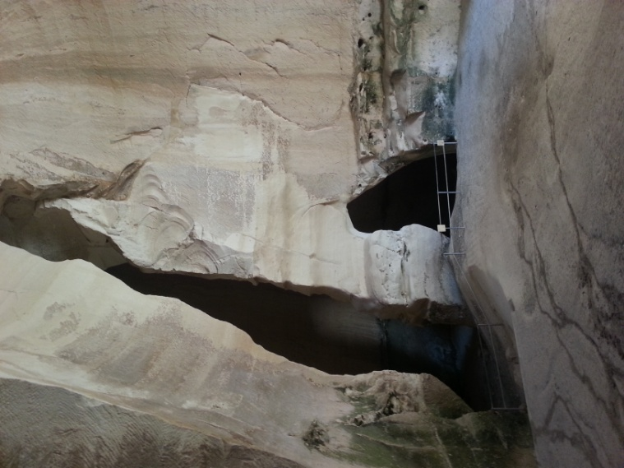Maresha Caves !!

- 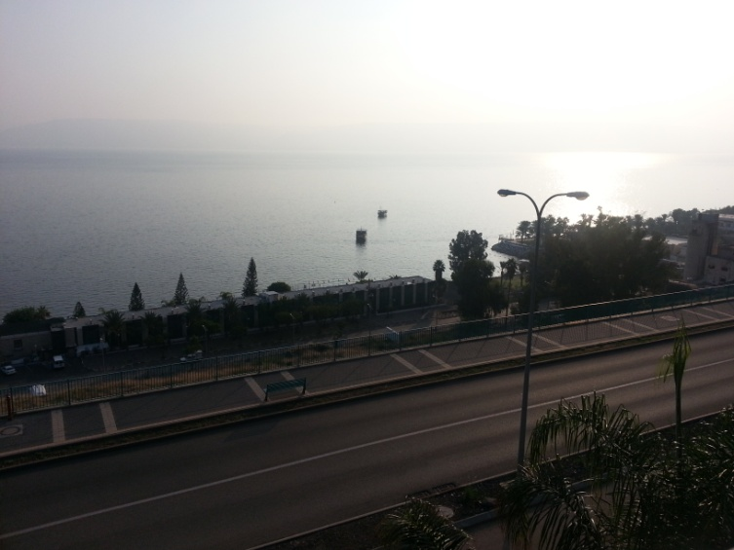 sea of Galilee
Tonight – Tuesday Nov. 18 th we are going to Nazereth to meet with some of the Arab Pators here in Israel. Please pray that we would make a deep connection and be an encouragement to them…

Thank you … pzie

Israel Trip Nov. 2014 -822 and tour

NOTE: Itinerary subject to changes.
- Arrive in Israel Nov.6, 3:15 pm

Upon landing in Israel, you will fly in from the west, over the Mediterranean coast and your first site of the land will be Tel Aviv or one of its suburbs, depending on the flight path and which side of the plane that you are sitting on.

The airport is located just a few kilometers southeast of Tel Aviv on the coast plain. This northern part of this plain, north of the Yarkon Stream, is called the Sharon Plain (on which Netanya is located) and just immediately south of the airport is the city of Lod. In the New Testament (this is transliterated from the Greek version of the Hebrew, into English, hence the different name) this city was called Lydda. One of the greatest revivals in the history of the faith occurred in this city and the region around it, as recorded in the book of Acts.

Acts 9:32-35, "Now as Peter went here and there among them all, he came down also to the saints who lived at Lydda. There he found a man named Aeneas, bedridden for eight years, who was paralyzed. And Peter said to him, 'Aeneas, Jesus Christ heals you; rise and make your bed.' And immediately he rose. And all the residents of Lydda and Sharon saw him, and they turned to the Lord."

As a result of the healing of Aeneas, who had been a paralytic for eight years, the entire region turned to the Lord. This is a remarkable extension of the kingdom.

You will be busy clearing passport control, retrieving your luggage, clearing Customs, orienting your way around the terminal and picking up your car rental. There is a money changer at the arrivals terminal if you need to get some shekels (Israeli money). Though you may be overtired and may feel like you are in a surreal world, it is very real. You are now in the land that our Heavenly Father promised to his covenant friend Abraham.

You are also ten hours ahead of your body's internal clock, which needs to be reset. You may be jet lagged. There is a key to rapidly resetting your internal clock. No matter how tired you feel, do not nap early when you get to your hotel. If you remain awake until your normal bed time, then you will adjust in a day or two to the new time zone. However, if you decide to nap early or in the day time, you will take longer to adjust. Melatonin can be a big help in adjusting. It is very safe and you can't overdose on it easily. I find that it makes me sleepy in about 20 minutes after I put it under my tongue.

As you drive to Netanya, you will be driving through the Sharon Plain (the Coastal Plain). Everywhere that you look is in a sense a miracle. A century or so ago, you would be traveling through an uninhabited wasteland, but you will see city's and towns everywhere. These cities exist, because the Lord has been and is bringing his people home, in fulfillment of promises that he made through the prophets.

Netanya is a modern, growing city on the coast. You will be staying at the Blue Weiss on the beach. You can ask for maps of the city at the front desk and ask for directions. If you turn left and walk north, as you exit the front door, you are about a five minute walk from a large plaza, with a fountain and if you walk the perimeter of the plaza you will find many shops, restaurants and fast food stalls.

At some point, you need to try falafel or shwarma. A lafa is a wrap and is larger than a pita. Sometimes there is a choice of meats. A good rule of thumb is to buy from a vendor who has a full spit. This means the meat is newly cooked. You will get to pick from a large selections of toppings and if you are unsure if you want something, then ask to taste a sample.

When you go swimming, I strongly encourage you to remain behind the t-shaped breakwater. This is designed to protect you from any strong undertows, that can be dangerous. In November, the water will be cooler than it is in summer, when it is lie a warm bathtub, but it will still be plenty warm for a Canadian.

- Netanya Nov.6/7/8
        - – 6- check in/ supper/bed :o)
        - /7th -beach – mall etc / free day relax (on Friday at noon, on the Sironit Beach below your hotel, there is salsa and Israeli folk dancing, children's programs and other performances.)
        - 8th - Caesarea

From Netanya, you may visit Caesarea National Park, Mount Carmel and Megiddo.

Caesarea is just a short drive north of Netanya on Highway 2. It will be spelled Qesarya or similarly on highway signs. In fact I think I've seen it spelled 3 different ways. The reason for this is that on the English part of the sign they put the transliteration of the Hebrew name and not the traditional English name, so the English spelling will be the same as it is pronounced in Hebrew.

Some places have more than one name through history. Akko is the New Testament city of Ptolemais and was also known as Acre in the Middle Ages, during the Crusades. I think I have seen Acco, Akko and Acre on signage.

The Valley of Elah might also be spelled Ela. Maps and GPS will help you find places as you travel through the land.

Caesarea was a city built by King Herod the Great on the site of a smaller town. It was a city of perhaps 100,000 people, which was a large city in New Testament times.

When you buy your entry passes, it is important to buy the ORANGE colored 2 week passes for every National Park in the country. These cost 150 shekels (written NIS 150, which is about $45 to $50 depending on exchange rates), but these will pay for themselves over the duration of your trip.

Also at the ticket booth ask for an English language park map and guide brochure for everyone in your group. Do this at every park that you enter.

There are some remarkable things to see in Caesarea. There is a large theater, where they found a stone with the name Pontius Pilate written on it. The original is on display the Israel Museum in Jerusalem, but there is a replica on display behind the theater at Caesarea. If you enter the city through the gate near the theater, then you will see Herod's palace (and later the palace of the Roman governor). On the left. You can see the floor of the throne room, where Paul may have addressed Felix, Festus and Agrippa and Bernice. You can still see the outline of the swimming pool. It is very possible that this is where Paul was kept under house arrest, at least initially during the more than two years that he spent here.

Acts 23:33-35, "When they had come to Caesarea and delivered the letter to the governor, they presented Paul also before him. On reading the letter, he asked what province he was from. And when he learned that he was from Cilicia, he said, 'I will give you a hearing when your accusers arrive.' And he commanded him to be guarded in Herod's praetorium."

Acts 24:23-24, "Then he gave orders to the centurion that he should be kept in custody but have some liberty, and that none of his friends should be prevented from attending to his needs. After some days Felix came with his wife Drusilla, who was Jewish, and he sent for Paul and heard him speak about faith in Christ Jesus."

Philip preached in Caesarea (Acts 8:40). Saul (Paul) sailed from here back home to Tarsus, when he was fleeing persecution (Acts 9:30). There was also a centurion named Cornelius, who was a God-fearer, who prayed and gave alms to the poor among the people. Those who bless the progeny of Abraham reap blessing and those who seek, find. As the Lord looked out over the earth, he selected this Jewish loving, God-seeker to be the first to hear and respond to the gospel, among all the Gentiles on the earth. Cornelius' story is told in Acts 10 & 11. So in a sense Caesarea is an ancient ruin that symbolizes us. It is where the first Gentile believed and was filled with the Spirit. He was the first fruits of a great harvest to follow, over the ages.

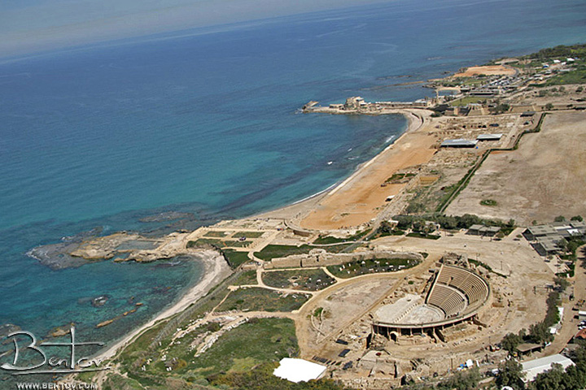
Other things to see at Caesarea, include the hippodrome on the beach, where chariot races took place. It was was a major port and the ancient harbor can be seen from the pier further north along the shore. The coastline is sinking, so you can see the remnants of the ancient harbor in the water off shore. This was the largest artificial harbor in the ancient world and it was made with concrete that cured underwater. Underwater concrete technology was later lost for about 1800 years, before it could be used again. There are warehouses, a temple to the emperor and the baths (a marble hot tub can be seen). You can also see the remains of the wall of the much smaller and later, crusader city with it's moat and sloped wall, called a glacis. The slope is so that catapult boulders would bounce off at an angle, minimizing the damage they could do.

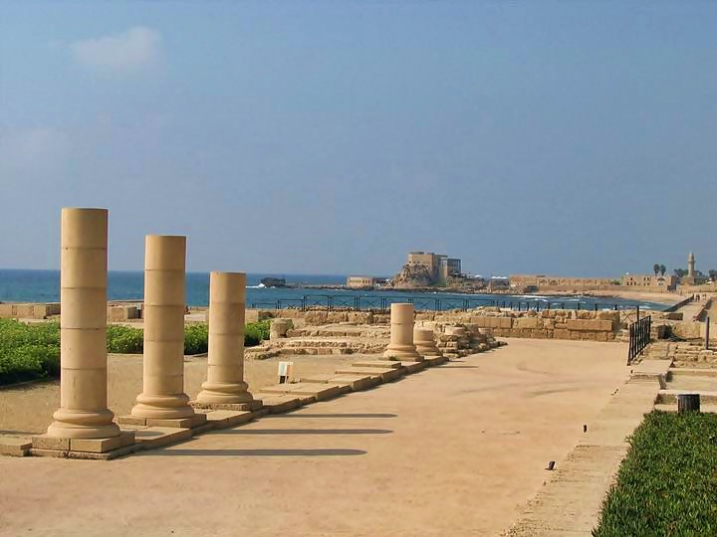
In this photo you can see the restored theater, the hippodrome on the beach. Where chariot races were held. On the first promontory is the palace. When you are there you will see the remnants of the swimming pool and a room where Paul possibly presented the Gospel to Felix, Festus and Agrippa. The further promontory is part of the ancient harbor. If you look in the water to the left, you can see the outline of the ancient foundations of the large harbor, which have been eroded by the waves over the centuries. They appear as dark shadows in the water.

Acts 25:23

So on the next day Agrippa and Bernice came with great pomp, and they entered the audience hall with the military tribunes and the prominent men of the city. Then, at the command of Festus, Paul was brought in.

This ruins of the building on the photo is part of the ancient palace and is likely the audience hall mentioned in Acts 25:23.

- Jerusalem Nov. 9/10/11/12/13/14
        - 9th Old City /western wall? -----get off the train at the City Hall stop on Yaffa Road and walk to the Jaffa (Yaffa) Gate. Then arrange a rendezvous point in case someone gets separated from the group, one convenient place is the Aroma coffee shop outside of the Jaffa Gate in Mamilla Mall, there is free wifi, they have great coffee drinks and blended cold drinks. The salads are really tasty and healthy and very large. They also have great sandwiches. Stop at the information office immediately upon going in the gate and get English maps for everyone of Jerusalem and the Old City. The information center is a good place to ask questions and for directions or other information. You can ask for directions to the booth, which is just around the corner, to buy tickets to walk on the walls and you can walk on the walls of the city all the way to the Jewish Quarter. This is relatively inexpensive and a very memorable experience, to be a watchman on the walls (Isaiah 62). There are two routes, a northern one that takes you to the Damascus Gate all the way to the Lion's Gate and a southern route that takes you around the Armenian and Jewish Quarter, where you get off before reaching the Dung Gate. Your ticket entitles you to walk both routes, which both start at the Jaffa Gate. I recommend the southern route, as it takes you where you want to go anyway and avoids the Muslim Quarter. At the ticket booth ask for directions about where to ascend the wall. Then turn right as you walk past the 2,000 year old fortress watchtower (part of King Herod's palace fortress and now a museum that features the history of Jerusalem) and walk past the Immanuel Messianic Gift Shop. It is owned by believers and is full of great books, Messianic music, videos and gift items. It's a good place to shop and bless the Body of believers as well. Then continue past Christ Church, which has a nice cafe called loaves and fishes. Christ Church also operates a Christian Guesthouse. It is a Charismatic pro-Israel outreach of the Anglican church, called CMJ or Christian Ministry to the Jews, which is the oldest Protestant church building in the Middle East, about 170 years old. This ministry is originally responsible for bringing the gospel to the Jews in Europe and Jerusalem and many of the early converts were the pioneers of the modern Messianic movement. CMJ also influenced many prominent church leaders and British politicians who established early foundations for the establishment of the modern state of Israel. Continue walking south past the Armenian tavern on your left, a good restaurant in which to try Armenian food. You are in the Armenian Quarter of the city. Take your first left on St James, which looks more like an alley than a street and continue walking east until you get to Hurva Square, where the new large, rebuilt synagogue with the domed roof is located. You will pass the ancient columned street of the Roman City. The city was renamed Aelia Capitolina after the destruction of AD 70, when the Romans rebuilt it. The Cardo was the main street of the city. The name of the large synagogue is Hurva Synagogue. From the square east of the synagogue it is a minute walk to see the Broad wall of the city built by King Hezekiah and mentioned in Nehemiah, when it was later rebuilt. It was built by Hezekiah, because they had to enlarge the city because of the influx of refugees, when the Assyrians invaded in about 701 BC. Hezekiah's water tunnel was built at the same time. There is a nice Judaica gift shop in Hurva Square, just around the corner from the Broad Wall, in the perimeter of the square called Shorashim. It is owned by two brothers, who are orthodox Jewish immigrants from Toronto. If you go into the shop, one of the brothers likes to give one or two minute teachings, which are very illuminating to interested customers. There are some nice restaurants and fast food places in and near Hurva Square. Ask for directions to the wall or follow the dark clothed pilgrims. As you walk to the wall from Hurva Square, which is a very short walk, you will pass the Golden Menorah, which has been prepared for the rebuilt temple. it is on public display under fairly high security, which may not be visible. The man who donated the money (several million dollars) to the Temple Institute to make it, insisted that it be put on public display. It is located at the top of the stairs leading down to the Western Wall Plaza, the Jerusalem Archaeological Park and the Dung Gate (which you will later exit to take the two block walk to the City of David National Park and Hezekiah's Tunnel). If you look up the stairs behind you just before you reach the Menorah, you should see the new much improved Temple Institute museum. I highly recommend this. You can go in and arrange for a tour and they will assign you a time, when you buy your tickets. You can come back for the tour about ten minutes before. This museum is much better than it was just three years ago. It is much better and they will explain things to you, which will open up your understanding to the Temple which played such s key role in both Old and New Testaments. You will see the furnishings and implements prepared for the next Temple. It is very enlightening. There are two other museums that you might consider in the Jewish Quarter, one is the Burnt House, the home of a priest that was destroyed in AD 70 and discovered as it was, after 1967. Incense for the Temple was manufactured in the home. They found part of the body of a young girl under the charred support beam that fell on her, when the Romans burned the city. The other museum is the Herodion Mansion, also called the Wohl Museum. This was a huge palatial home, that likely belonged to one of the wealthy chief priests during the time of Christ's ministry. It too was discovered when the Jewish Quarter was being rebuilt after being repossessed in 1967. Another option of something to see is the Western Wall Tunnels. It is probably the most remarkable thing to see in the Old City, other than Hezekiah's tunnels and the City of David National Park. It is by appointment only, but you can stop by the office to see if there is an opportunity, during the day or your stay. One thing that is very interesting that takes only a few minutes is the large wall mural on the street from the time of Jesus, that is at the south side of the stairs down to the plaza. If you head out of the security gate and then turn right before you get to the dung gate, you will see the 2,000 year old street that Jesus almost definitely walked on. There is a large mural on the street that shows a typical street scene in the New Testament period, which Jews call the period of the Second Temple.
        - 10th– Israel Museum // evening 822 Gathering/. The Israel Museum is huge. It is a very short drive from your hotel and also within walking distance. It has a nice snack bar, where you can buy an inexpensive lunch. There are three separate parts that you will want to see. The large outdoor model of Jerusalem in the time of Jesus, which is based on the best historical and archaeological discoveries. It will help you translate the things you see in the Old City to what they looked like in the time of Jesus. The second thing is the shrine of the book, with a number of the Dead Sea Scrolls in display, as well as other artifacts that were recovered at Qumran, where the scrolls were found. The complete two thousand year old scroll of Isaiah is on display (although it had been removed on our most recent visit for restoration and replaced with a replica). This is the only part of the museum whee photographs are not permitted. The third must see part of the museum is the Archaeological wing. The Old Testament periods and New Testament periods are those I find most interesting. You will see miniature household Baal and Asherah idols, Seals belonging to people in the Bible, ostraca and reliefs with ancient Hebrew writing, such as mention of the House of David, Senacherib's boast, ancient coins. One thing I found most interesting is the necklaces worn by priests of Baal is the same symbol that tops almost every mosque in the world. You will also see the oldest quote from the Bible in existence, two amulets that were made about 700 BC, that contain the priestly blessing and were found in a tomb where they had been placed on the necks of two corpses. In the New Testament period section, you will see things that were in the Temple (signs and a parapet with writing), the heel bone of a crucified man, with the crooked nail still embedded in it. You will see a stone sign with the name of Pontius Pilate and the ossuary used to bury the high priest Caiphas, as well as many other interesting things. There are coins mentioned in the Bible. Take particular note of the Denarius from the time of Jesus, which will open up your understanding to one story in the ministry of Jesus. You are now permitted to take photos, since the museum was reopened a couple of years or so ago. You will visit ruins as you travel the country, but this is where the artifacts found in those ruins have been brought and the best of which are placed on display.
        - 11th -13th Gathering/
        - 14th Hezekiah’s tunnel, / Garden tomb: 2 pm appointment

- Neve Zohar Nov. 15/16 -
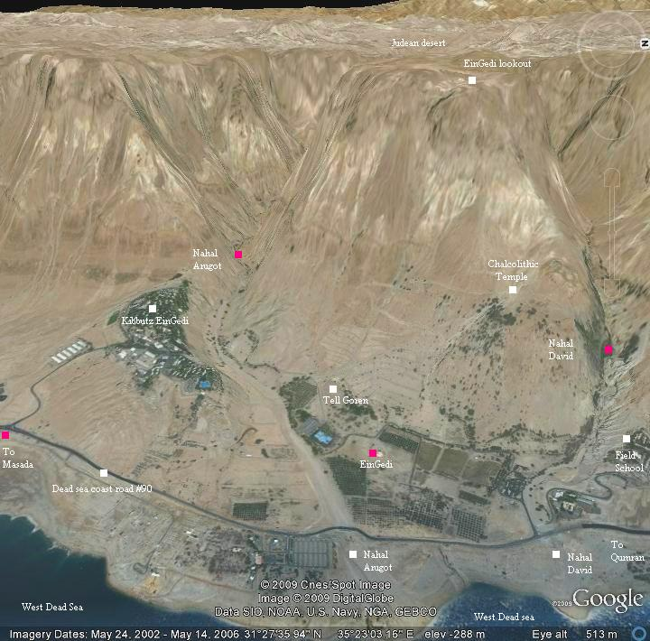
        - 15th - Engedi, [hike] /Massada [tram up] .. Dead Sea ---- You might need to change the settings on your GPS to drive to En Gedi, because technically you are crossing the Green Line. After you leave the Park Hotel, get on the Begin Expressway going north, until you get to Highway 1 and take Highway 1 all the way to the Dead Sea and follow the signs and when you reach when you get to Highway 90, stay to the right and head south towards Masada and Eilat on route 90. En Gedi (which means Spring of the Goat) is the largest desert oasis in Israel, at 250 acres. The desert soil is very fertile, when it is irrigated. En Gedi is in the tribal allotment of Judah.

Your orange colored National Park pass will gain you entrance to En Gedi. Here are some Scriptures that mention En Gedi.

1 Samuel 23:29 - 24:4, "And David went up from there and lived in the strongholds of Engedi. When Saul returned from following the Philistines, he was told, 'Behold, David is in the wilderness of Engedi.' Then Saul took three thousand chosen men out of all Israel and went to seek David and his men in front of the Wildgoats' Rocks. And he came to the sheepfolds by the way, where there was a cave, and Saul went in to relieve himself. Now David and his men were sitting in the innermost parts of the cave. And the men of David said to him, 'Here is the day of which the Lord said to you, "Behold, I will give your enemy into your hand, and you shall do to him as it shall seem good to you."' Then David arose and stealthily cut off a corner of Saul's robe."

Song of Songs 1:14, "My beloved is to me a cluster of henna blossoms in the vineyards of Engedi."

Ezekiel 47:9-10, "And wherever the river goes, every living creature that swarms will live, and there will be very many fish. For this water goes there, that the waters of the sea may become fresh; so everything will live where the river goes. Fishermen will stand beside the sea. From Engedi to Eneglaim it will be a place for the spreading of nets. Its fish will be of very many kinds, like the fish of the Great Sea."

En Gedi is featured in the Biblical narrative of King Saul and David. It was one of David's hiding places, where he cut off the corner of Saul's garment. It is mentioned in Song of Solomon in a manner that alludes to its fertility. It is also mentioned as a place where men will fish in the Dead Sea, after the river flows from the Temple and heals the Dead Sea.

You can take the hike up Nahal David (David's stream) to the upper falls, at that point you can't walk any further up the canyon or wadi. You may see Ibexes (Wild Goats) as you hike. It is somewhat challenging, but to make it to the upper falls is very rewarding. I recommend that you walk up to the water falls on the north side of the stream and walk back on the south side, for the best views in both directions.

Just across the road and a bit south is one of the best places to swim in the sea. It is free to swim there, but costs money to use the change room or to rent a towel. There are showers located on the beach, so you can rinse off the salt before it dries in your pores and makes you itch. There used to be a very good restaurant located at En Gedi, but there is a small snack bar. There is also a restaurant in Kibbutz En Gedi located nearby.

Masada is you next stop and is one of the most remarkable historical sites in Israel. King Herod built a massive impregnable fortress on top of the mount. Your orange colored national park pass will get you access to the site, but the two way gondola ride is an extra purchase.

Here is Josephus' account of what occurred here in AD 70.

Wars of the Jews VII Chapters 8,9

Josephus Flavius was a former Jewish commander in the Galilee (named Yosef Ben Matityahu - Joseph, son of Matthias). He surrendered to the Romans in Yodfat (Jotapata), and became a famous Roman historian in the court of Rome. The siege and fall of Masada are detailed in Josephus accords, and are partially listed below.

"When Bassus was dead in Judea, Flavius Silva succeeded him as procurator there; who, when he saw that all the rest of the country was subdued in this war, and that there was but one only strong hold that was still in rebellion, he got all his army together that lay in different places, and made an expedition against it. This fortress was called Masada. It was one Eleazar, a potent man, and the commander of these Sicarii, that had seized upon it..".

...

"For now it was that the Roman general came, and led his army against Eleazar and those Sicarii who held the fortress Masada together with him..."

...

"There was a rock, not small in circumference, and very high. It was encompassed with valleys of such vast depth downward, that the eye could not reach their bottoms; they were abrupt, and such as no animal could walk upon, excepting at two places of the rock, where it subsides, in order to afford a passage for ascent, though not without difficulty".

...

"Upon this top of the hill, Jonathan the high priest first of all built a fortress, and called it Masada: after which the rebuilding of this place employed the care of king Herod to a great degree; he also built a wall round about the entire top of the hill, seven furlongs long; it was composed of white stone; its height was twelve, and its breadth eight cubits; there were also erected upon that wall thirty-eight towers, each of them fifty cubits high; out of which you might pass into lesser edifices, which were built on the inside, round the entire wall; for the king reserved the top of the hill, which was of a fat soil, and better mould than any valley for agriculture, that such as committed themselves to this fortress for their preservation might not even there be quite destitute of food, in case they should ever be in want of it from abroad. Moreover, he built a palace therein at the western ascent; it was within and beneath the walls of the citadel, but inclined to its north side. Now the wall of this palace was very high and strong, and had at its four corners towers sixty cubits high. The furniture also of the edifices, and of the cloisters, and of the baths, was of great variety, and very costly; and these buildings were supported by pillars of single stones on every side; the walls and also the floors of the edifices were paved with stones of several colors. He also had cut many and great pits, as reservoirs for water, out of the rocks, at every one of the places that were inhabited, both above and round about the palace, and before the wall; and by this contrivance he endeavored to have water for several uses, as if there had been fountains there. Here was also a road digged from the palace, and leading to the very top of the mountain, which yet could not be seen by such as were without [the walls]; nor indeed could enemies easily make use of the plain roads; for the road on the east side, as we have already taken notice, could not be walked upon, by reason of its nature; and for the western road, he built a large tower at its narrowest place, at no less a distance from the top of the hill than a thousand cubits; which tower could not possibly be passed by, nor could it be easily taken; nor indeed could those that walked along it without any fear (such was its contrivance) easily get to the end of it; and after such a manner was this citadel fortified, both by nature and by the hands of men, in order to frustrate the attacks of enemies".

"Since therefore the Roman commander Silva had now built a wall on the outside, round about this whole place, as we have said already, and had thereby made a most accurate provision to prevent any one of the besieged running away, he undertook the siege itself,..."

"Accordingly, he (Silva) got upon that part of the rock, and ordered the army to bring earth; and when they fell to that work with alacrity, and abundance of them together, the bank was raised, and became solid for two hundred cubits in height. Yet was not this bank thought sufficiently high for the use of the engines that were to be set upon it; but still another elevated work of great stones compacted together was raised upon that bank; this was fifty cubits, both in breadth and height."

"At the same time Silva ordered that great battering ram which he had made to be brought thither, and to be set against the wall, and to make frequent batteries against it, which with some difficulty broke down a part of the wall..."

"When Silva saw this, he thought it best to endeavor the taking of this wall by setting fire to it; so he gave order that the soldiers should throw a great number of burning torches upon it: accordingly, as it was chiefly made of wood, it soon took fire; and when it was once set on fire, its hollowness made that fire spread to a mighty flame."

"Eleazar ...... gathered the most courageous of his companions together, and encouraged them to take that course by a speech..."

" ... slay their own wives and children with their own hands...these people died with this intention, that they would not leave so much as one soul among them all alive to be subject to the Romans".

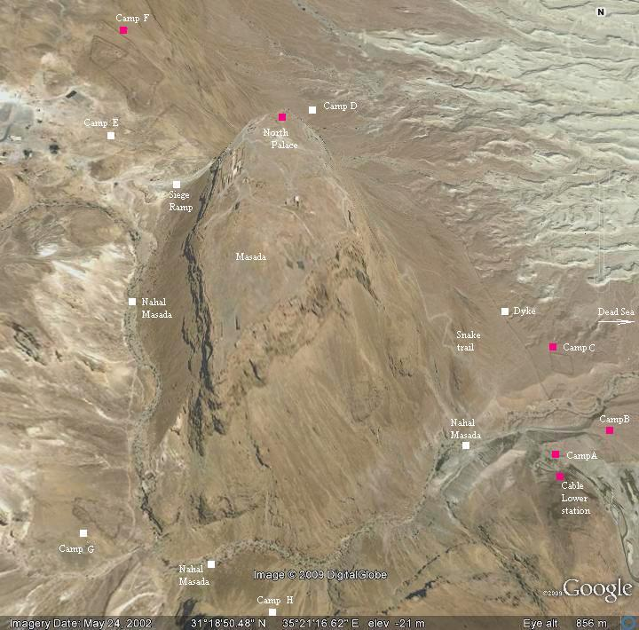
"Now for the Romans, they expected that they should be fought in the morning... they came within the palace, and so met with the multitude of the slain, but could take no pleasure in the fact, though it were done to their enemies. Nor could they do other than wonder at the courage of their resolution, and the immovable contempt of death which so great a number of them had shown, when they went through with such an action as that was".

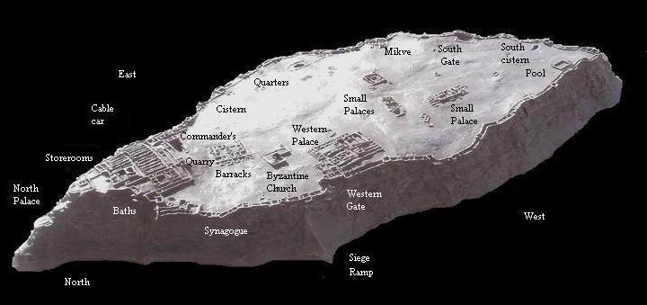
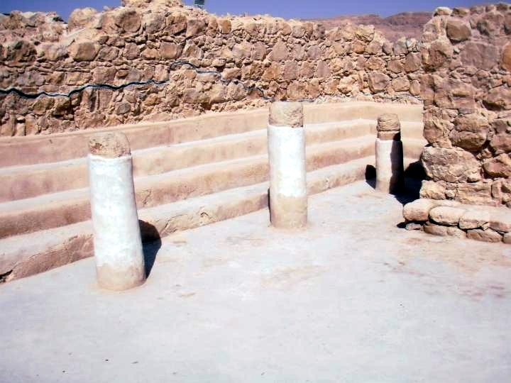
Some of the highlights to see on top of the mountain fortress are the storerooms, the baths, the northern hanging palace, the synagogue, the siege ramp, the Western Palaces and the huge southern cistern.

I highly recommend that you take the stairs down the side of the mountain to the hanging palace and take the stairs down inside the massive southern cistern.

From the top of the mountain you can see the wall the Romans built around Masada and the Roman camps.

I have included a photo of the synagogue at Masada. After Israel became a nation they found a portion of the scroll of Ezekiel buried in the synagogue, Ezekiel 37:1-14, about the dry bones.

16th – Boskey’s / Abraham’s well … visit the ruins there, and perhaps go to the desert if time permits. On your way to Avner's you may want to stop at Tel Arad, which would take about a half hour or so. You can walk through the ancient fortress, from Old Testament time, to see the Temple to the Lord, which was built here, in ignorant disobedience to the Scriptures, perhaps. The archaeological evidence suggests that I was ordered buried by King Hezekiah, who tore down the high places. Because it was a Temple to the Lord and not Baal it was not destroyed, but rather buried. It was a small version of the Temple in Jerusalem. Them continue on for your meeting with the Boskeys, which should be one of the highlights of your trip. Ask Avner any questions that you have been pondering on your trip about the Bible, history, the land, the end times, etc. He is very witty, with Ziemer-like wit and he is very gifted and knowledgeable. But He will usually only give you information that you ask for. He is literally the cleverest man that I have ever met, but he is humble and very gifted musically and spiritually. He is also a license tour guide, as well as being a Bible scholar (Dallas Theological Seminary graduate). He and Rachel are very likable. Avner was born and grew up in Montreal and speaks a number of languages. Hopefully they will take you to see Tel Beersheva and Abraham's well. I suggest that you go to Nafi's at the mall in Beersheva for lunch. It is reasonably priced with a wide variety of menu items, with very tasty food and huge portions. It is one of the highest rated restaurants in Beersheva. Perhaps you can offer to take the Boskeys, if they are able. I think they are headed to Nashville to do some recording the next day. One of their friends is Ricky Skaggs, who is a believer and he has recorded with them on one of their albums. They are very close friends of Jim Goll, who lives in Nashville.

- Tiberius Nov. 17/18/19/20
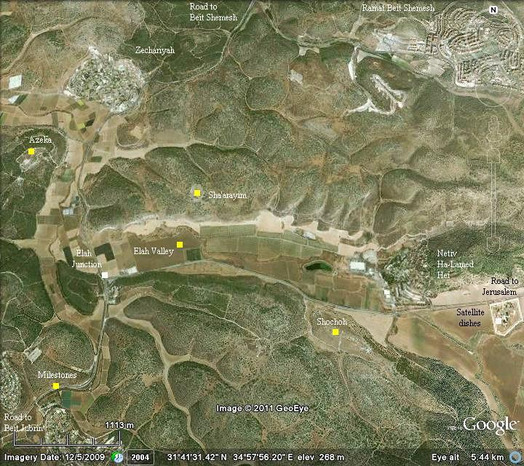
        - 17th travel with stops to Tiberius./ Tel Maresha caves. Valley of Elah ---- Nov. 17th…. Another exciting day! … we will travel from Neve Zohar to Tiberias in the Galilee making some stops along the way … This is about a 300 km drive. We will take the Neve Zohar to Beer Sheva then up to Tiberias route so we can visit the places we want to see. First stop is Tel Maresha caves … totally awesome sight to see!
        - The other stop we are planning is the valley of Elah; this is the site of the story of David and Goliath….

Valley of Elah

Here is a Satellite photo of the Valley of Elah (which means Terebinth tree), with some of ancient cities mentioned in the text of 1 Samuel 17. If you are driving up from Beersheva and Tel Maresha, then you will be driving up the highway from the southwest on route 38. There is a service station with a convenience store located in the hill just prior to Elah Junction. I suggest you turn right at thee junction and head east on route 375, turning around at your first opportunity and then driving back towards the junction. You can see where the brook Elah crosses the valley and is close to the road. Pull over as far to the right as you can and stop. Be very careful exiting the vehicle as the shoulder is not wide and traffic moves very quickly. I suggest you crossover the fence, if the weather allows and walk over to the stream bed. Read 1 Samuel 17 together. It won't take that long. You are standing in the immediate vicinity of the place where David killed Goliath. It happened somewhere within a few hundred meters of where you are standing. There are three key cities, on the map in the valley, two of which have been positively identified with certainty and the third with a high degree of probability. Tel Azekah and Socoh have been positively identified and Shaaraim, is most likely located at the recent dig on top of the hill across the valley from where you are located. Shaaraim means two gates and the fortress city on top of the hill has two gates in the wall, which unheard of for a city that size in 1000 BC. This city was only occupied for a period of about 80 years, about the time of Saul and David. There is only a single layer of occupation, unlike many other archaeological digs which have multiple layer. A ostracon (clay shard) was found there, written in Hebrew, that was a letter to the ruler of the city from the king.

This shard has been thoroughly studied and a likely translation is:

1. you shall not do [it], but worship the [Lord].

2. Judge the sla[ve] and the wid[ow] / Judge the orph[an]

3. [and] the stranger. [Pl]ead for the infant / plead for the po[or and]

4. the widow. Rehabilitate [the poor] at the hands of the king.

5. Protect the po[or and] the slave / [supp]ort the stranger.

This indicates the king sent instructions to the rulers of the city to take care of the poor in accordance with the Torah.

They found many olive pits at this archaeological site that they were able to radiocarbon date to the time of David, about 1000 BC. They also found hundreds of animal bones and they were all kosher animals. They have also found hundreds of jar handles marked with a symbol that indicated they belonged to the king, as taxes. This indicates this was a government fortress city and a regional center for collecting taxes and the ostracon likely indicates the poor were to be cared for perhaps at the expense of the king, from the taxes, which were paid as a portion of agricultural produce, stored in large pottery jars.

I think it is this archaeological evidence, that indicates the Israelites were most likely on the north side of the valley, prior to the battle, near their fortress city.

The text also suggests that the Philistine were camped on the south side of the valley, from Socoh around to Azekah.

Read the story and enjoy. May the Lord give you fresh insights!

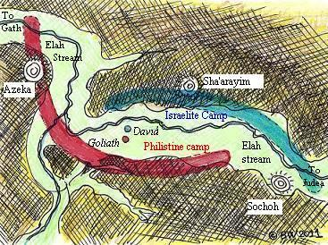
1 Samuel 17:1-3, "Now the Philistines gathered their armies for battle. And they were gathered at Socoh, which belongs to Judah, and encamped between Socoh and Azekah, in Ephes-dammim. And Saul and the men of Israel were gathered, and encamped in the Valley of Elah, and drew up in line of battle against the Philistines. And the Philistines stood on the mountain on the one side, and Israel stood on the mountain on the other side, with a valley between them."

1 Samuel 17:51-52, "Then David ran and stood over the Philistine and took his sword and drew it out of its sheath and killed him and cut off his head with it. When the Philistines saw that their champion was dead, they fled. And the men of Israel and Judah rose with a shout and pursued the Philistines as far as Gath and the gates of Ekron, so that the wounded Philistines fell on the way from Shaaraim as far as Gath and Ekron."

When you have finished your meditations in the Elah Valley, you should drive back to the Elah Junction and turn right (north). You will have several options for routes.

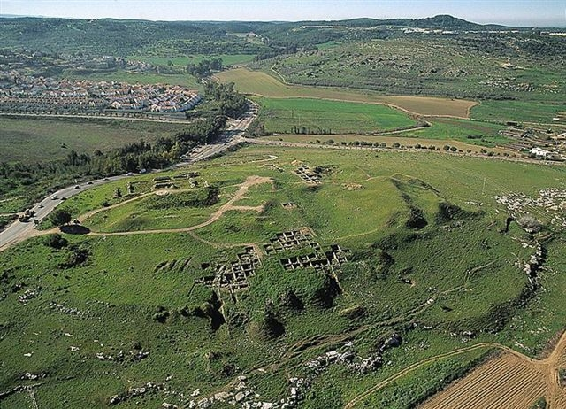
I suggest you continue driving another 10 minutes or so, as far as Beth Shemesh. You might want to stop briefly at Tel Beth Shemesh, which is just on the left hand side of the road. You might want to take a few photos. From the Tel looking north and northwest you can see where Samson was born and grew up, as well as the site of the Philistine city, where he found his bride.

I suggest you continue driving another 10 minutes or so, as far as Beth Shemesh. You might want to stop briefly at Tel Beth Shemesh, which is just on the left hand side of the road. You might want to take a few photos. From the Tel looking north and northwest you can see where Samson was born and grew up, as well as the site of the Philistine city, where he found his bride.

I recommend stopping at Cafe Rimon at the Big Mall in Beth Shemesh for a late lunch. It is the top rated restaurant in Beth Shemesh. There are some other eating options at the Big Mall. The Big Mall is located just off of route 38. Turn right at route 3855 and take your first left onto HaHarasha Street at the traffic circle and you will be at the Big Mall. There is also a Cafe Cafe in Beit Shemesh, but I am not sure where it is located.

The top photo is an aerial view of Tel Beth Shemesh looking south. You will be driving on route 38 from the top of the photo towards the bottom and Tel Beth Shemesh will be on your immediate left. If you elect to drive right by, it will be just beside the road.

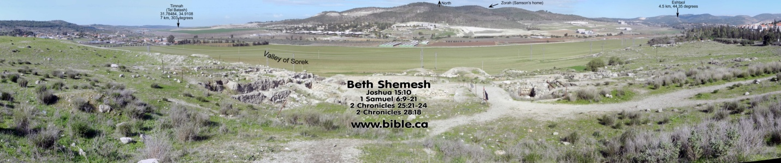
The second photo is a panorama shot taken from atop Tel Beth Shemesh looking north, where you can see where Eshtaol, Zorah, and Timnah are located.

This is the valley where Samson released the foxes. When we were here last year, Aaron saw a fox, about thirty seconds after we talked about the foxes in the story.

This is also the city, to which the captured ark of the covenant was returned on an ox cart. Many men died here, because they looked inside the ark. Beth Shemesh was a Levite city and the Levites should have known better an not permitted it. Beth Shemesh was a border city on the boundary between they tribal allotments of Judah and Dan. It would have been populated with Levites, Danites and Judaeans in Old Testament times.

When you look north and west you are looking into the territory of Dan. As you can see through your travels, Dan was given the fertile coastal plain, the very best part of the land. But they were unable to dispossess the Philistines and Amorites from the plain and due to their difficulty possessing their inheritance, they gave up and traveled to the far north of the nation and settled there, in a part of the land that was actually given to Dan's brother Naftali. They found an area that was very lush and fertile and easy to possess. However, they later reaped what they sowed. Dan was a center of idolatrous worship from the very beginning and was repeatedly the first part of the land conquered by the invading armies. Dan refused to exercise the faith necessary to possess their God-given inheritance and settled for something that appealed to them that was easier. However, in the list of tribes in Revelation, at the end of the age, Dan is not mentioned. Like Esau, Dan forfeited their inheritance. This is one of the tragic stories of Scripture. Samson was a prototypical Danite, he also forfeited his full destiny, through his backsliding, though he experienced some redemption at the end of his life.

        - 18th – morning relaxing at the Sea of Galilee/ Evening: visit HOPE Nazareth/ Arab Pastors@ Golden Crown

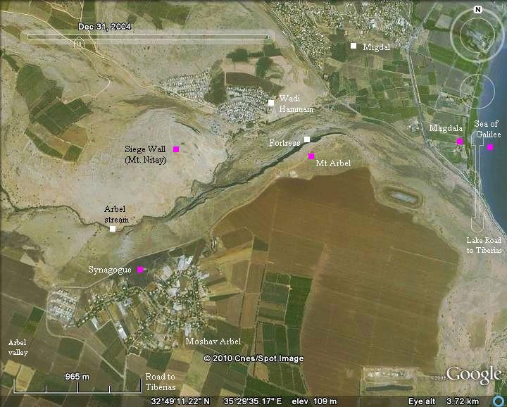
There is a Messianic gift shop on the Waterfront called The Galilee Experience. There are lots of little gift shops, boutiques and food stalls and restaurants near the water front in Tiberias, along the waterfront promenade. The Galilee experience is on the second floor, to the left, of the large building built on the pier that extends out from the shore. It is operated by believers and a good place to buy gifts to bring home, especially if you want to plant seed in the concept of Christian bookstores.

In the afternoon, there are two places you could stop on route to Nazareth.

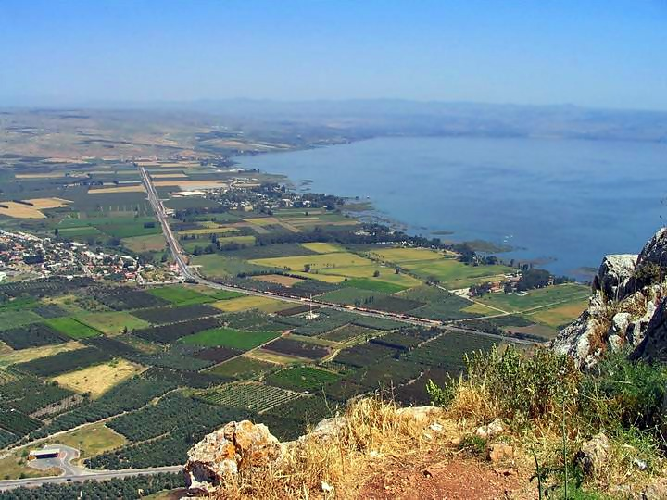
This photo is part of the spectacular view from the Arbel Park.

The one I would recommend most is Mount Arbel National Park. This is just a very short drive from Tiberias and your orange card gains you access. From the parking lot it is a short walk up the gradual slope of the hill to the lookout, by the soul carob tree. It is possibly the most remarkable view in Israel, looking out over the area, where Most of Jesus ministry, as recorded in the gospels took place. It is a very possible site of the events on the Galilean mountain, near the sea, mentioned in Matthew 28, where the Lord uttered his great commission. This would not be a lengthy stop and it is just off the route between Tiberias and Nazareth.

The other place that I would recommend is Nazareth Village and it is best to phone ahead and make an appointment for a time for an English tour. Allow an hour from Arbel to get to Nazareth, in case you get lost driving in Nazareth, which is not too hard to do. Also, the traffic in Nazareth can be quite congested. Google maps says it is a 36 km drive and will take about 48 minutes.
        - 19th - boat ride on the Sea of Galilee/ Capernaum/ Mount of Beatitudes/ .[join M&W] [evening: Arab Pastor. Nazareth?]

Tel Dan National Park

Here is another option available to you, instead of visiting Yardenit, after your boat ride on the Sea of Galilee and a stop at Capernaum, which are must see experiences, I suggest you drive north toTel Dan (I remember Marty making this suggestion to you too), the beginning of the Jordan River. It is 56 kilometers and a 46 minute drive from Capernaum to Tel Dan, if you take route 90 north and your Orange colored national park passes will gain entrance. (It is a 30 minute drive to Yardenit, from Capernaum, with traffic, so it isn't much longer to drive to Dan, time wise. Going north will allow you to see Mount Hermon, most probably the real Mount ofTransfiguration. I doubt that you will have time to make more stops, but if you did, you could make a quick stop at the first century city of Caesarea Philipi National Park, located just 3 km or so east of Tel Dan. This is where Jesus was immediately before climbing the very tall mountain and was transfigured. It is where he made the famous statement about the gates of hell not prevailing against His church. Everything is very close to the parking lot there. Just another short drive further east is what is called Nimrod's Castle National Park, a most amazing Crusader period castle, which you can walk through and explore. You could make your return drive back to Tiberias south through the Golan Heights and see a different part of the country.

Or you could take an alternative route to Nazareth driving through Safed (Tzfat) a most unique city, over Mount Canaan and then south, seeing some different part of the country.

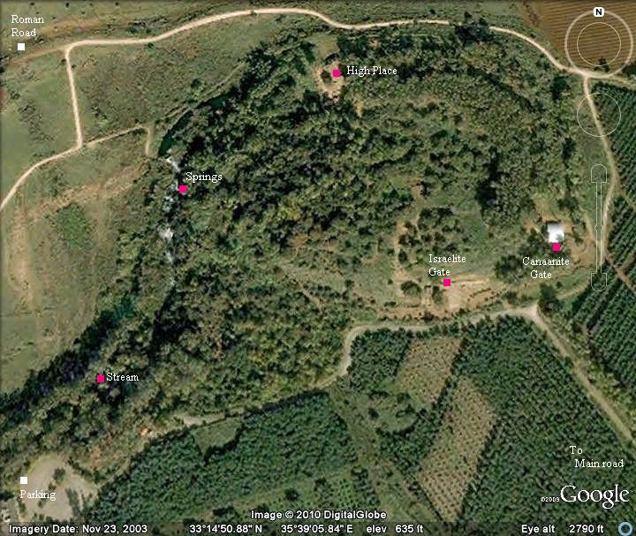
Here is an aerial photo of Tel Dan, one of three sources of the Jordan River and a large fresh water spring and site of numerous Biblical stories.

Tel Dan is the lushest, most naturally verdant place in Israel. There are several highlights, a 4,000 year old gate that was possibly used by Abraham, when he was there. There is an Old Testament period elaborate gate structure and perhaps the most significant thing to see is the Temple of the Golden Calf built by King Jeroboam. You also will see the largest fresh water spring in the Middle East, the largest of three sources of the Jordan River. The water bursts out of the ground at Dan. There is a trail back from the Temple to the parking lot, where you walk beside the river.

When you are standing on the platform, where the golden calf stood, then you can look out from the hill to the north and see where the border with Lebanon is located a kilometer or two away.

Dan

Location and Setting
  - Located near the southwestern slopes of Mount Hermon, Dan was an ancient Canaanite city originally known as Laish (Judg 18:29) or Leshem (Judg 19:47). The tribe of Dan migrated to the area during the early days of the Judges era, took the city, and gave it their tribal name.
- As the northernmost city of Israel, the name of the city, together with Beersheba in the south, defined the borders of the land, "from Dan to Beersheba" (Judg 20:1).
- Dan was strategically situated on the road from Damascus in Syria to Tyre on the coast of the Mediterranean Sea. The north-south route from Hazor to Lebanon passed through Abel-beth-maachah, just west of Dan.
- Dan stood at the northern end of the very fertile upper Jordan Valley, one of the most productive regions of the land. This location also made it vulnerable to invasions from the north, which was the approach traditionally used by Mesopotamian powers.

Historical and Biblical Significance
- The territory allotted to the tribe of Dan after the Conquest extended to the Mediterranean coast (Josh 19:40-47). This included the strategically important International Coastal Highway and the area controlled by the Philistines. When it became impossible for the tribe to possess their territory or even to defend themselves against the pressure exerted by the Philistines in the Shephelah (Judg 1:34), its members sought a more secure location.
- The tribe sent five spies to search for a suitable place for the tribe (Judges 18). Ultimately they selected Laish, which they conquered and possessed (Josh 19:47). Not all the tribe of Dan migrated to Laish. Some, including Samson and his family, remained in the disputed territory, continuing their contacts with the Philistines. Eventually this remnant was absorbed by the tribe of Judah (2 Kgs 15:29).
- The events of the transition (Judges 18) and subsequent choices resulted in the tribe of Dan’s becoming the most idolatrous of all the tribes.
- Idolatrous worship practices were established in Dan during the priesthood of Moses’ grandson, Jonathan, and were continued by his descendants (Judg 18:30). The city finally became a national center of idolatry under Jeroboam I (1 Kgs 12:29-33).

Scripture References

Deuteronomy 34: 1; Judges 18: 29; Judges 20: 1; 1 Samuel 3: 20; 2 Samuel 3: 10; 2 Samuel 17: 11; 2 Samuel 24:2,15; 1 Kings 4: 25; 1 Kings 12: 29,30; 1 Kings 15: 20; 2 Kings 10: 29; 1 Chronicles 21: 2; 2 Chronicles 16: 4Genesis 14: 14; Jeremiah 8: 16; 2 Chronicles 30: 15; Jeremiah 4: 15; Ezekiel 48: 1,2,32; Amos 8: 14

        - 20th- [join Michael/Wanda] – Megiddo / Kehilat HaCarmel Worship Centre Mount Carmel… [possible evening meeting with an Arab pastor in Nazareth]

- Tel Aviv Nov.21
        - 21st – check out > >To Tel Aviv / hang out- beach/supper
        - 22nd … depart early morning 22nd need to be at airport by 2 am!

