Glen and Cindy Mueller’s Trip to Lolat, Papua, Indonesia – February, 2015
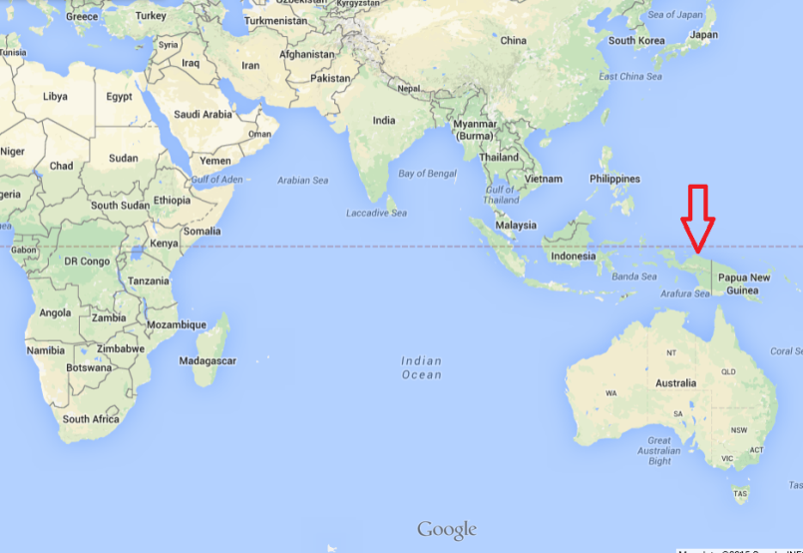
In February Cindy and I (Glen), traveled to Papua, Indonesia to visit friends that have worked as missionaries there for the past 40 years. We were also able to fulfil a dream that we’d had for years: To return together to the village of Lolat, high in the mountain jungles, to where Cindy and her family went in 1980.
Many don’t know where Papua, Indonesia is. It’s located right above Australia, and is on the left half of the Island that is shared by New Guinea. This area used to be called Irian Jaya. It’s a part of Indonesia that is very culturally different from the rest of Indonesia.

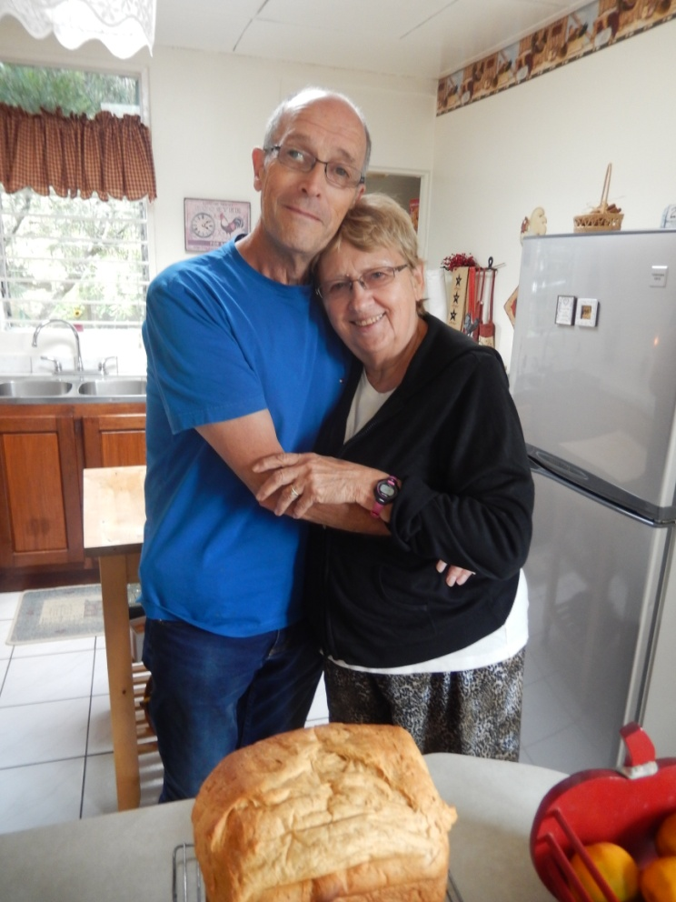
In 1980 when Cindy and her parents traveled to Lolat to help the Clarks, the people were still living a stone-age existence, including warring with neighbouring villages, practicing cannibalism, and worshipping a god which they called Kembu. This demonic witchcraft had such a hold on the people, and their lives were heavy with fear and violence. It was just 10 years before Cindy’s visit that the men of the valley had killed the first 2 missionaries to their area with their arrows, and cannibalized them.
The people also wore very little clothing according to western standards, but have now found that the one outfit they may own provides them warmth as the village is at about 7,000 feet elevation.
It was amazing to see how the Lord had used Art and Carol and the others working in neighbouring valleys, to bring the gospel of peace to these beautiful people. When we visited earlier this year, the people were full of thankfulness as they continually told the story of how they and the rest of the Yali people had received the gospel that was brought to them.
We were able to fly from Wamena into the village in a small fixed wing and visit the village of Lolat for 4 days. When we landed at least 200 people walked up the runway to welcome us. Over the past 35 years there had only been 4 or 5 other white people that had come to the valley, and when they heard that Cindy was coming back they wanted to see if it was true.
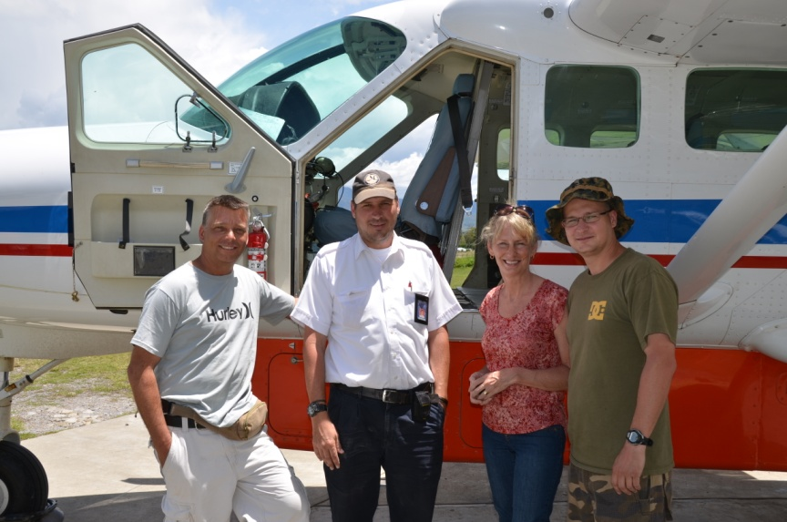

Many remembered her and couldn’t wait to hug her, hold her hands, and touch her hair. They honored her by giving her a Yali name which means, “The white girl who came back to the black people”.
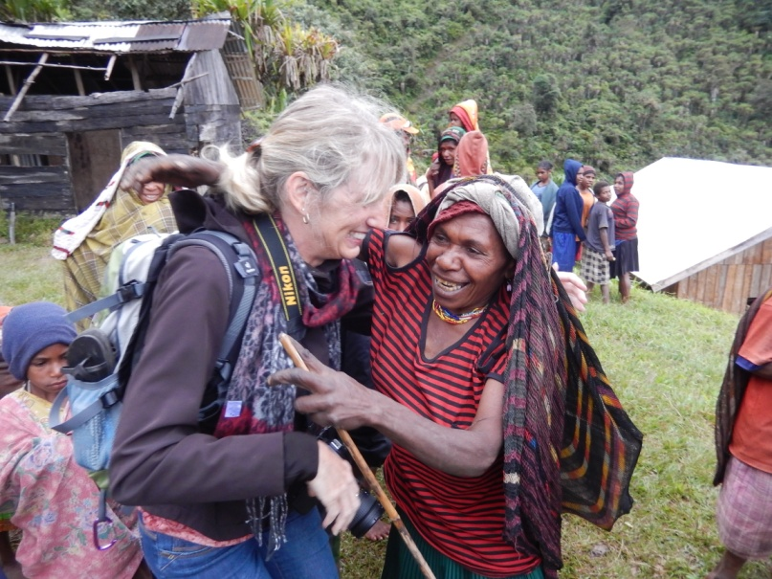

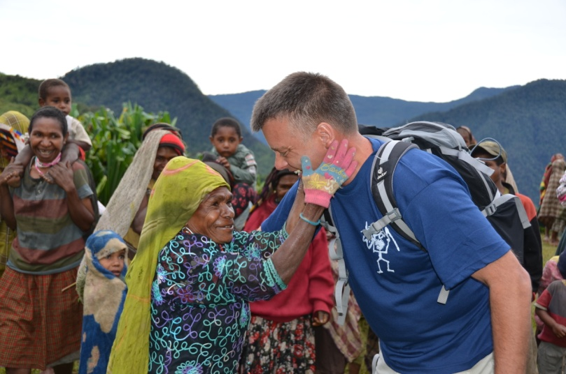
Even though they hadn’t met me, they were so welcoming, and gracious during our visit.
I loved the hugs that older women gave, and the people were so thankful that we had come to see them.

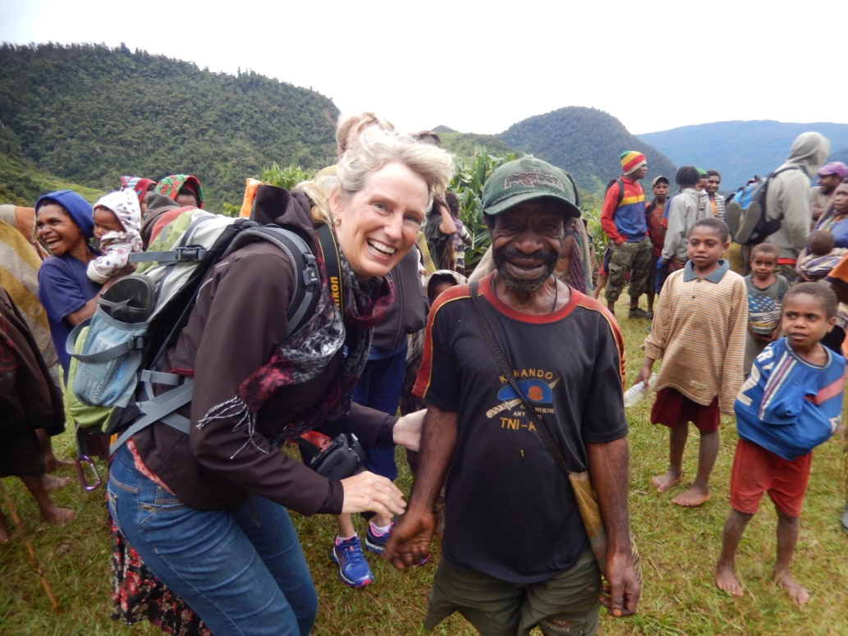

Many of those who came to welcome us had been young children or teens when Cindy and her family had been in the village 35 years earlier, so it was an exciting reunion.

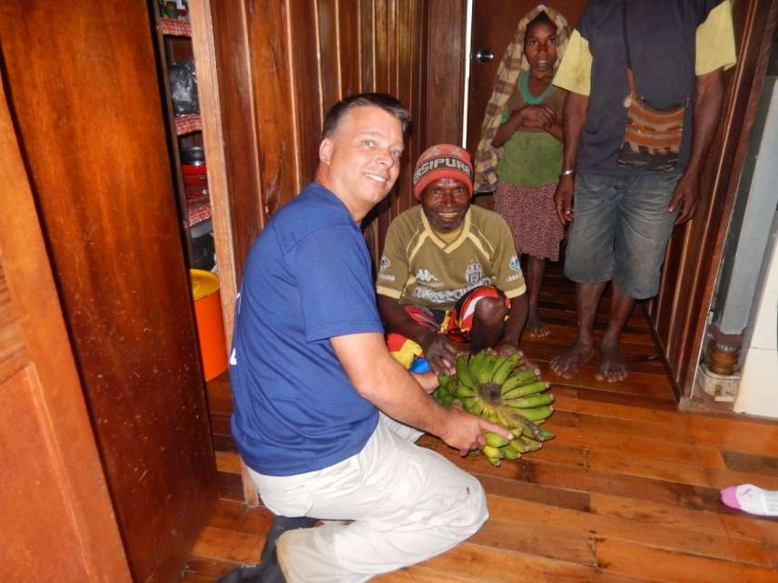

One example of how amazingly kind and thoughtful the people were, was when this man brought this bundle of bananas as a gift for us. We found out he had walked barefoot for two days through the jungle just to bring us this gift from another valley.

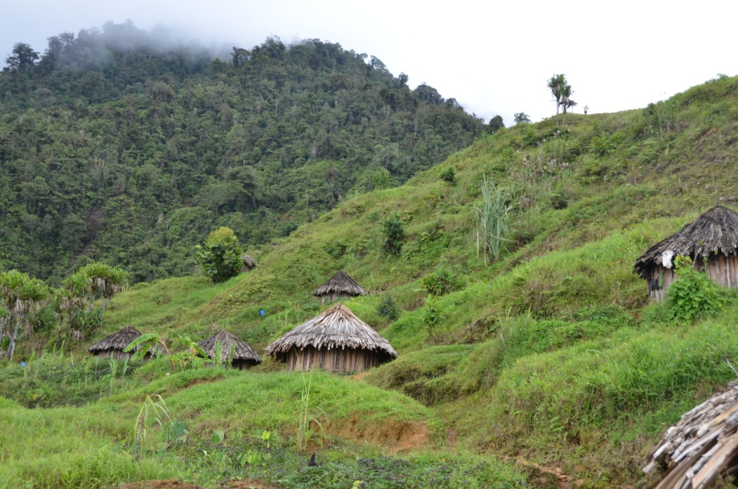

In the valley we visited there are about 1,500 people who still live in traditional huts and garden the hill sides for potatoes and other vegetables.

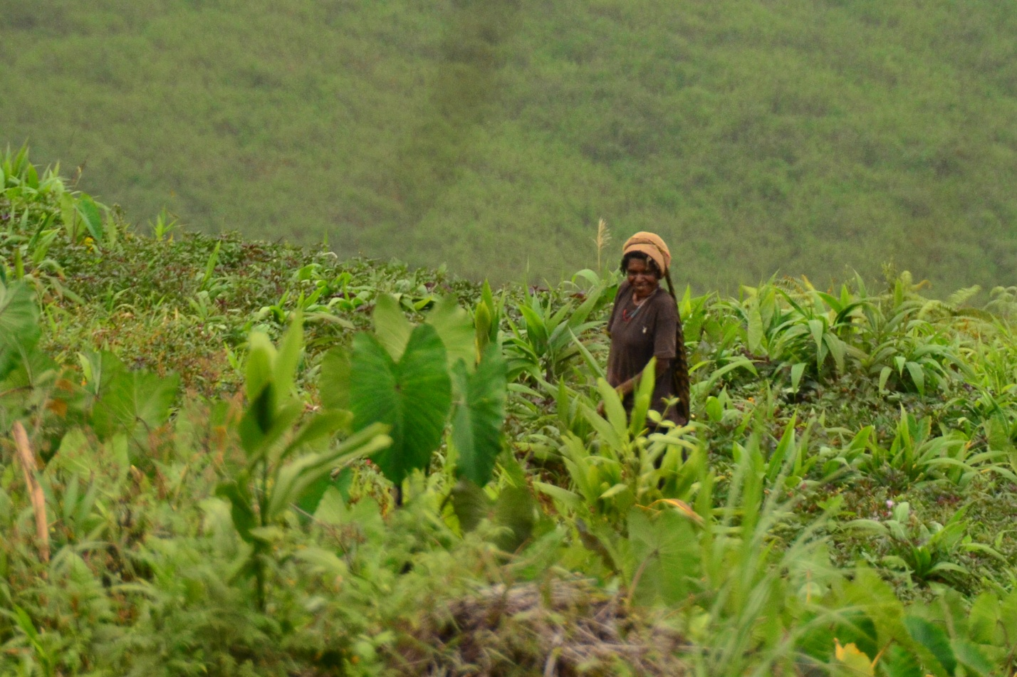

Even though it rains almost every day, the people travel up to 2 kms to work their gardens. In the past this work has been done only by the women, but now the men share the work in the gardens.

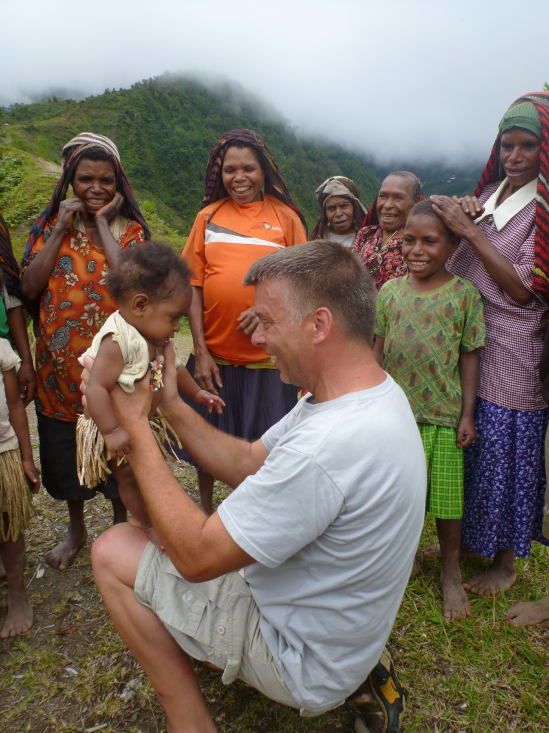

Everywhere we went there were people who would take the time to greet us. I loved hugging the older women and the young children. This little girl was so beautiful in her grass skirt.

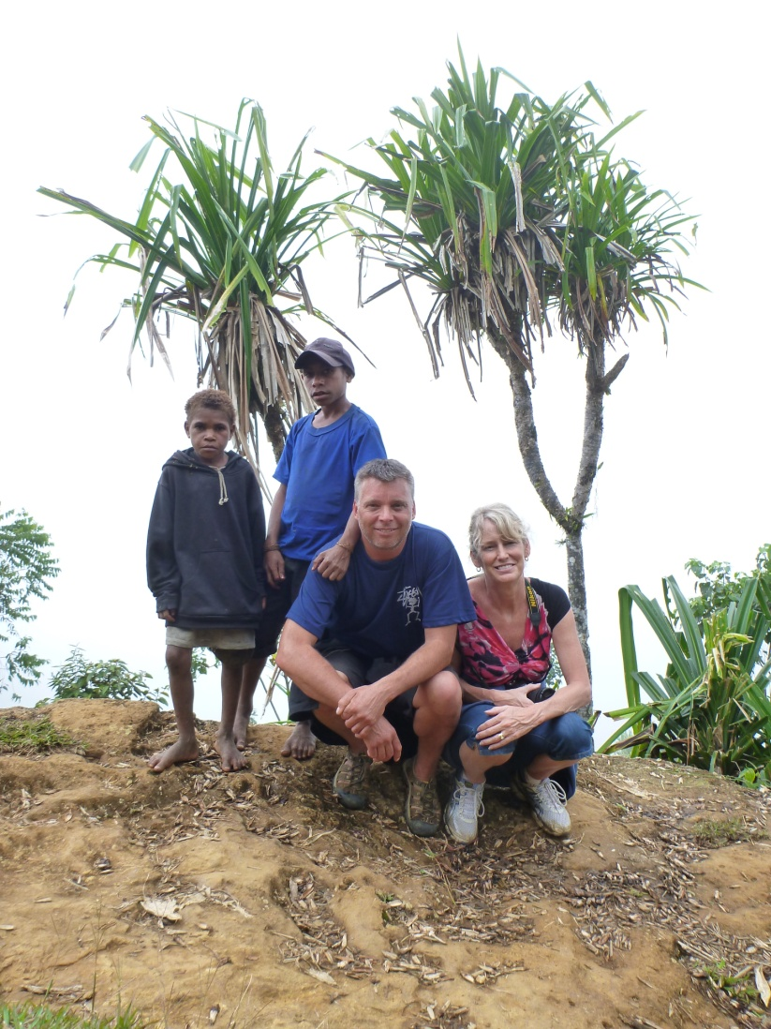

It was sad to notice though that it appeared that there were so very few young people left in the villages. Apparently the lure of the city had drawn the majority of the young people to make the 10 day walk through the jungle out to the city where there were rumors of money and a better life. Of course for most what they find is unemployment, alcohol, gambling, AIDS, and a life of violence.

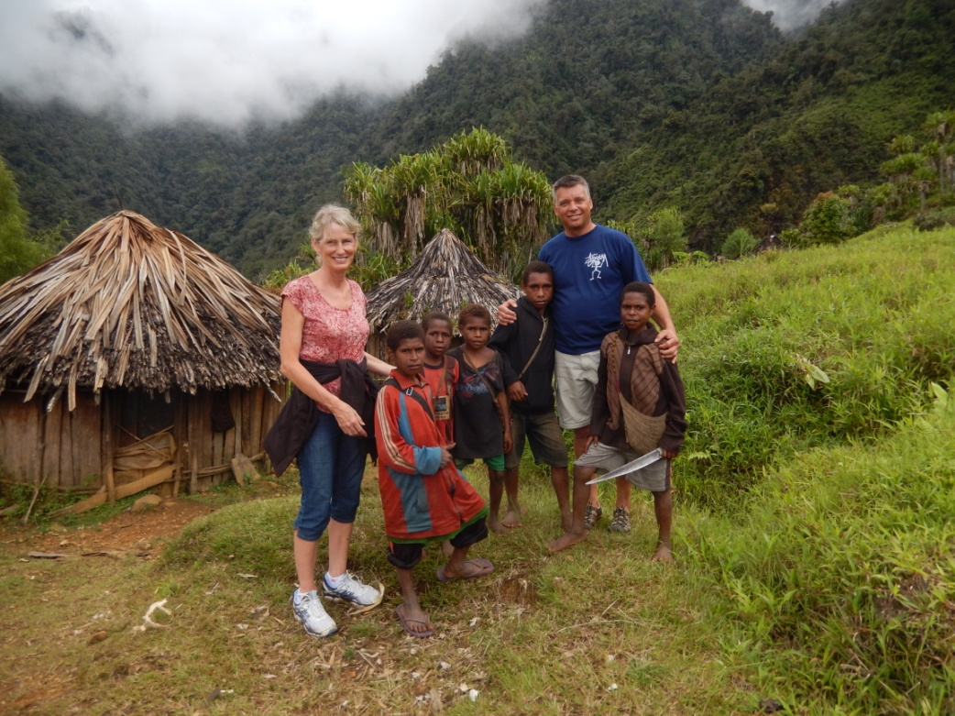
One afternoon when Cindy and I took a walk these young boys gave us a tour of the hillside.
They were full of laughter and were pleased we had come to visit. They also loved compairing our soft feet to their calloused feet.
At first we were surprised to see how many children carried machettes around all day, but we soon found out that they used them to cut off branches with fruit so they could eat while walking on the trails.
One day we had the privalege of being treated to a pig feast. We enjoyed seeing how the meal was cooked in a hole in the ground with hot rocks. The main diet in these valleys consists of potatoes and a few vegitables, so a meal including pig meat was very rare and special.
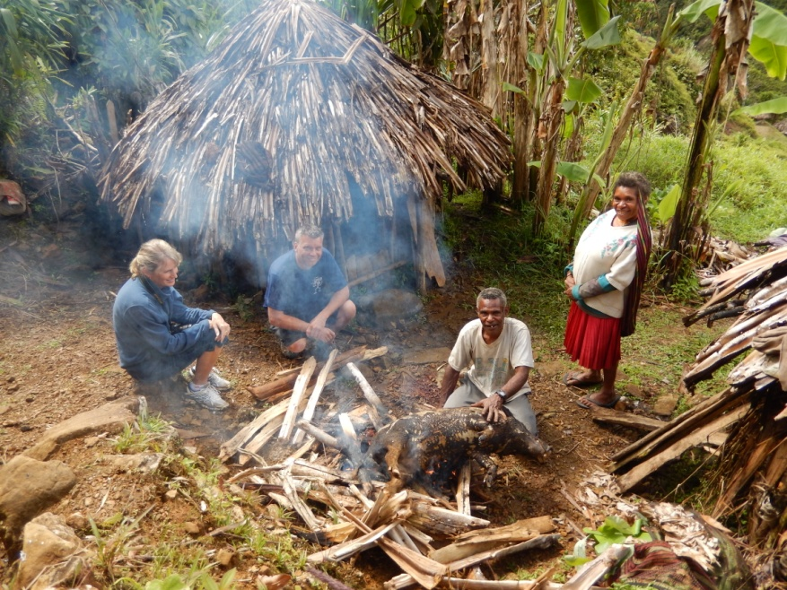

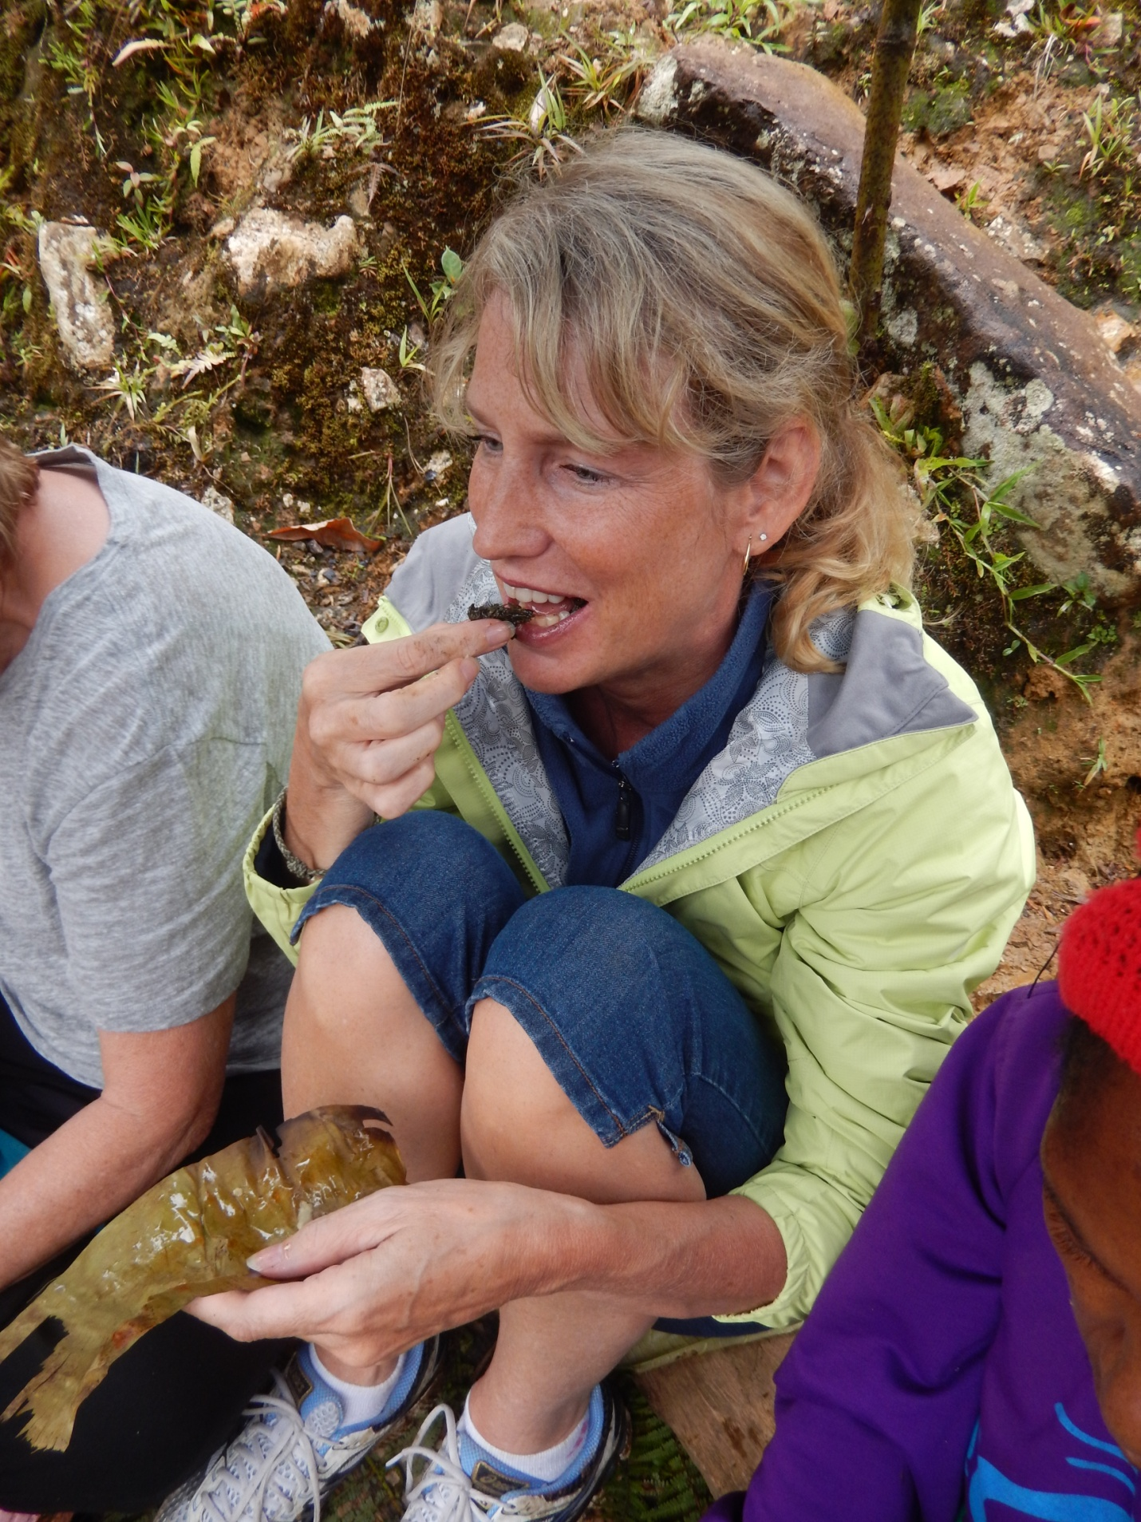

Art and Carol explained that this might be the only meal with meat that these people would have that month.
We could see that the people lived with very little. A hut that might be 8 feet in diameter, would be the home for 4-6 people. In the hut would be a place in the center for a fire pit, and along the sides would sit a couple pots, some fire wood and a knife and machette.
The majority of the people only had one or two pairs of clothes, and the food was harvested daily from the fields.

When the missionaries had come to these valley’s in the mid-sixties there were no believers and the people were filled with fear. But almost everywhere we went people had smiles on their faces and wanted to tell us about how the gospel had come to their valley, and how they had accepted the good news of Jesus.
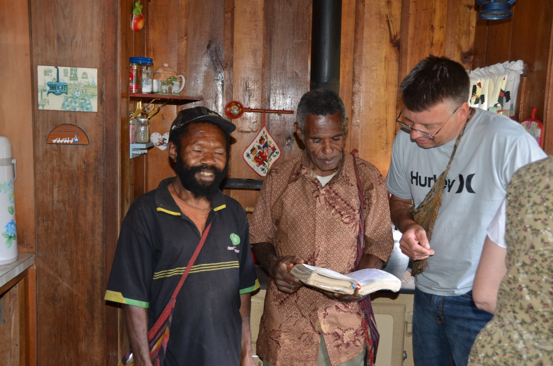

I became instant friends with these two men. The man on the left is Sabahon and is the son of the tribal chief who was one of the first to respond to the gospel. When Cindy was in the village 35 years earlier Sabahon was just a young boy but he was so excited that Cindy had returned. The other man is Lehesa. When Cindy’s family was in Lolat 35 years earlier they remember him helping carry fire wood for Art and Carol. He is an amazing man who is full of the joy of the Lord. He is an evangalist who travels to other villages sharing the good news of Jesus Christ with other tribes. Here he’s showing me his Bible. The translation was just completed about 10 years ago.

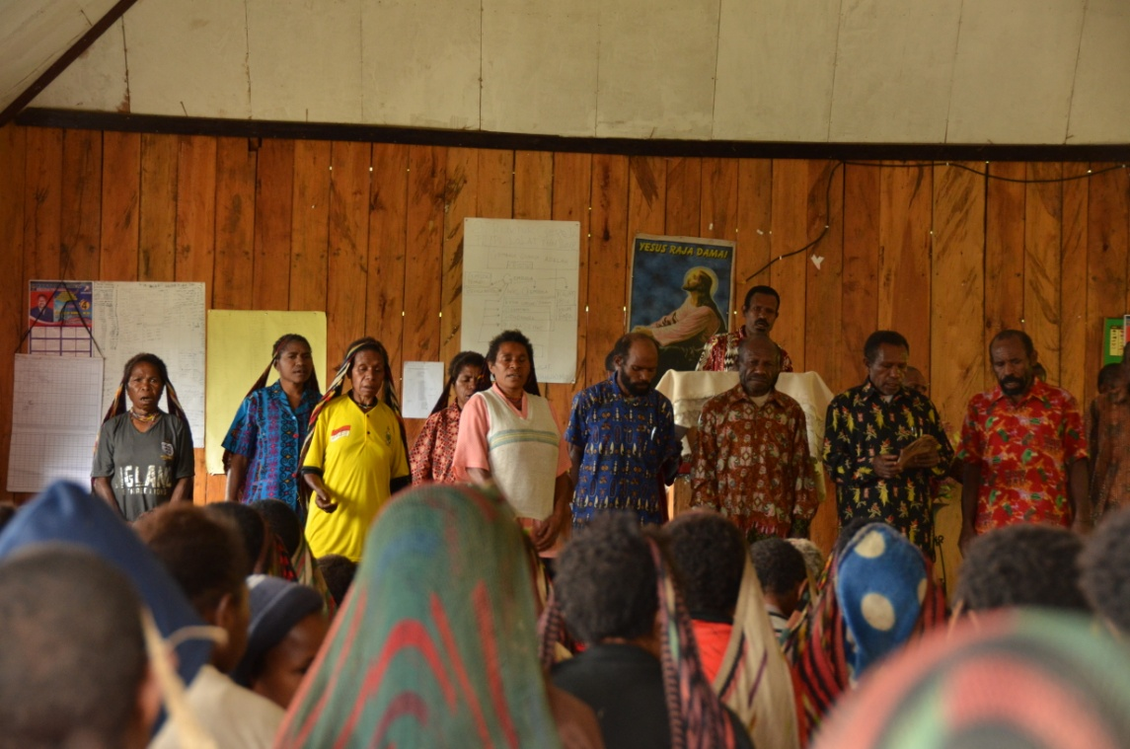
We were pleased to see that there was a vibrant church in the village.
On Sunday morning we were blessed to join them as they sang worship songs in the traditional way (without any instruments). It was a beautiful sound! And to hear a message from a man, who most likely was a warrior just 35 years earlier, speak of how the people continued to get thirsty after drinking from the local streams, but that they would never thirst again after drinking from the spring ofLiving Water who was Yeshua.
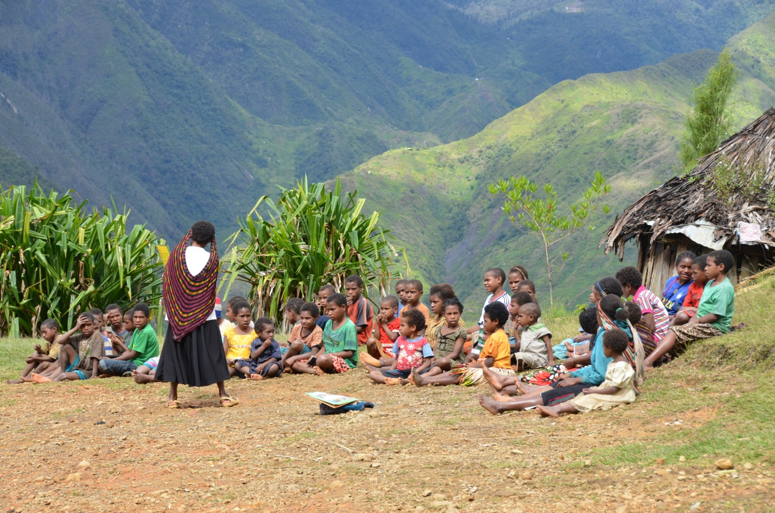

We enjoyed seeing the young children playing each day, whether is was sunny or rainy. On Sunday morning the children from the village gathered and had “Sunday School” out on the helicopter pad. They sang songs and were taught a story and lesson from the Bible.
There is a book that was written about the missionaries who first entered the Seng Valley in the late ‘60s called ‘Lords Of The Earth’, written by Don Richardson (also the author of Peace Child). I had read this book in 1983 and was astonished by the the fear and violence that surrounded the people of this area. At the time the chief was a warrier named Sio. I met his son and asked him how many men he had killed and canabbalized, and he said there were so many that no one could remem er as the number was too high. One of the high lights of our visit was to see a cross on the side of a hill with his name on it. The people didn’t know his age, but it seemed like he had always been with them, so they put his age as 1040 years. What was more amazing than this, was the story of how Sio had chose to, in his own words, “walk on Jesus’ path”. He was one of the first to turn to Christ in the valley, and as a result many many more have also chose to believe and follow Chirst.

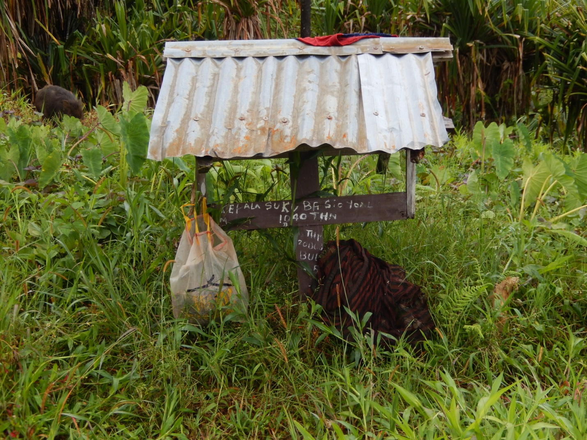

It was so great to be able to walk the valley, and almost physically feel that the fear and hatred had been lifted from the people, and in spite of a hard existence, the people were now experiencing the peace and joy and freedom that the Lord provides.
After our short time in Lolat we returned to the nearby city of Wamena where Art and Carol now live and minister. Here Cindy and I meta young Christian man named Lemius who had been born in a nearby village, but had grown up in Wamena and lead to the Lord by Art and Carol. He was amazing and full of the joy of the Lord.
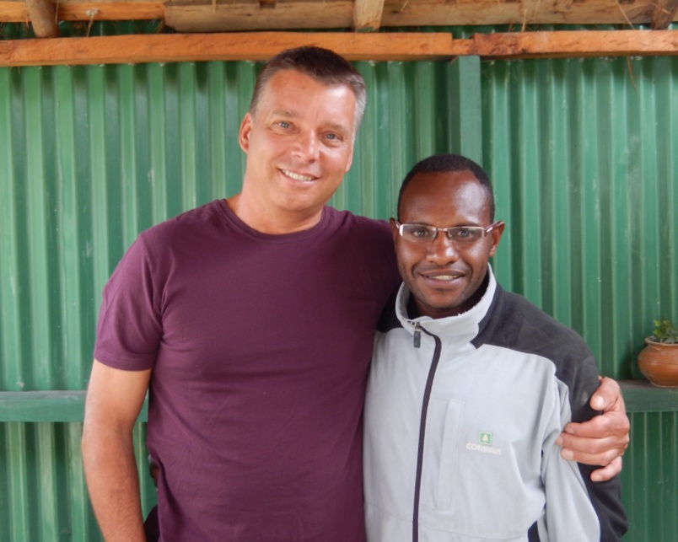

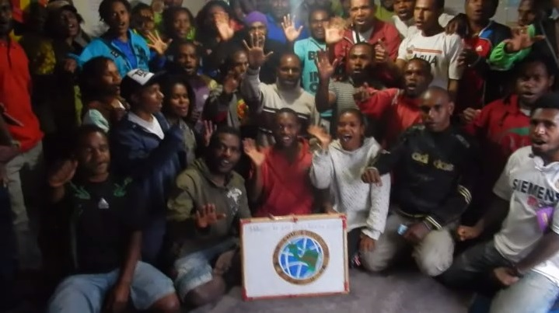
I was able to meet with a group of his friends that are choosing to reach out to the youth of Wamena as well as the children and young people of 22 nearby villages. In a time where violence and revolution seem to be the natural choices in Papua, these young believers are choosing a better way – to share the love of Jesus.
Cindy and I consider ourselves very furtunate to be able to make a trip like this. Not only were we able to encourage our friends Art and Carol, who have served faithfully for so long, but we were blessed to see how the gospel of Jesus Christ is relevant to all people in every part of the world. We were amazed to see how individual lives and entire villages were transformed by the love of God.

We aren’t sure when we will be able to return to help with the work in this area. Art and Carol say there are at least 10,000 people in this and neighboring valleys that are without any medical help, and many have yet to hear the gospel or read the Bible in their own language. Please pray for Art and Carol, for Lemius, and the other believers who continue to walk the hills of the jungle spreading the good news.
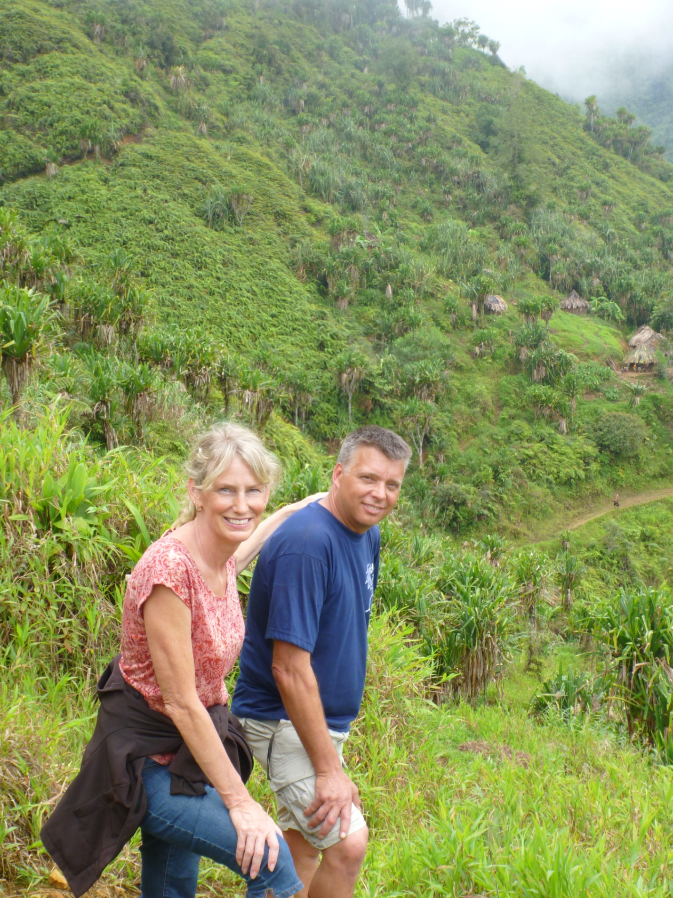

How beautiful on the mountains are the feet of those who bring good news, who proclaim peace, who bring good tidings, who proclaim salvation,
who say to Zion, "Your God reigns!" Isaiah 52:7

