http://www.thewell-pgbc.com/

Japan Gathering May 3-6 /2015
[ >>> scroll down for more]
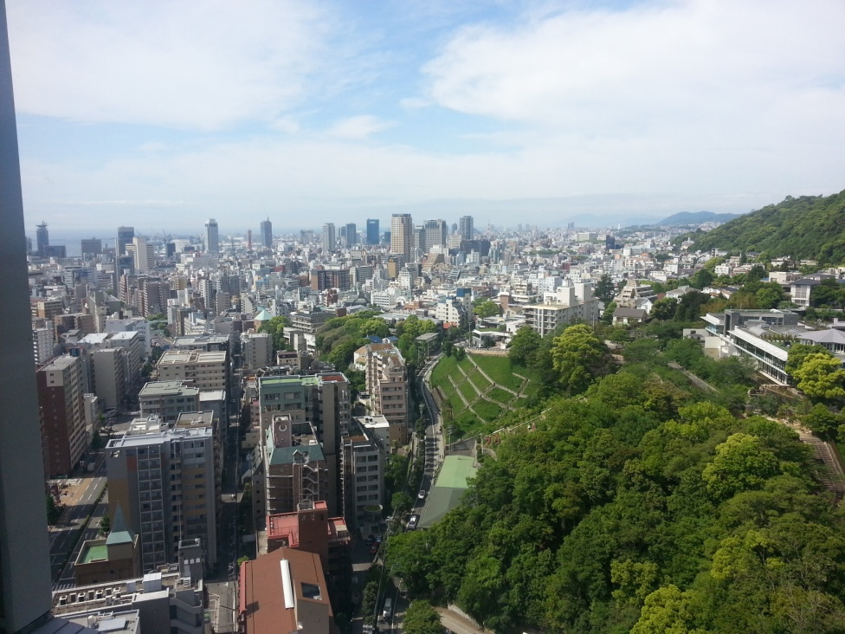 > Kobe Japan

….. 9:24 am here Sunday May 3rd. Trying to wake up and have a shower:). On the 25 the floor. It is amazingly quiet. No street noise Have not even heard a single person in the hallway. We had a lovely flight over. Air Canada Rouge flight. Apparently it was their inaugural flight to Kobe and they had a big table of sushi and cake at the gate, as well as Japanese dancers. Our pg connection was close so we didn't have time to enjoy it. Just went from gate to gate:). The plane was nice, one thing I had never seen was the lighting that changed slowly from soft pink to purple to blue, very subtle and relaxing. It's those little touches!

Crazy day for transportation: Ray drove us in his truck to the airport. We flew to Vancouver and then to Kansai airport, Then took a shuttle to the water, where we took the fast ferry across (30min) to the Kobe airport side. From there we took another shuttle to the rail transit and traveled to the convention centre/hotel where many were staying. We stashed our luggage and got back on the rail with the group (about 13of us) and rode down to the end to the restaurants and downtown Kobe basically. Went to a restaurant where pretty much no one knew more than 5 words of English, one of them being 'chicken' and the other being 'salad' and had a great time. We ordered chicken skewers and a salad. ( my 'no meat salad' turned out to be white strings of vegetable and a wedge of tomato with slivered sesame chicken. Tasty tho). Then we took the bus shuttle back to the hotel (by this time it was about 4 am bc time) and got our luggage and took a taxi to our hotel. Got to bed about 5:30 am I think

So let's recap:
Truck, plane plane shuttle ferry shuttle rail rail bus taxi. There was a whole area of bikes for rent and we did joke a little about that being the only thing besides a horse that we hadn't ridden today!!
Today is another day:). Little bit overcast but inviting nonetheless.
Going to explore the garden walk behind the hotel. There is also a gondola that takes us up the mountain if we want to try that:)
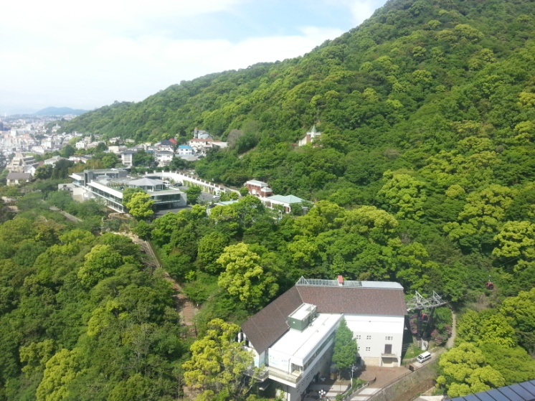 > if you look close you can see the gondola bottom right
Love all you much! Don't know that I will bore you with a diary entry every day but I thought day one sounded interesting lol ….

#2
…. We won’t tell you what time we got up Sunday morning :o) - we had been up for 22 hours and we are not quite as young as we use to be! Our friends from Regina are staying in the same hotel as us so we meet them in the lobby and went out to explore a bit. Found a grocery store and had a blast trying to figure out what to buy when there is very littleto zero English on any labels. Then we wandered around amongst many millions of people trying to find a place to eat … we found a nice little spot and had some chicken curry with rice … really gooood! Then we found a Starbucks and had a coffee together talked and prayed together [prayed for healing for our friends feet :o)
Then it was time to transit back to the International Convention Centre which we found after some time of wondering around again … we began to meet up with many friends from Canada and around the world - there really is a global body of Christ who love the Lord with all their hearts and are living for the King! … about 4000 people from 31 nations!
We went to the discernment meeting and then right into the open pre-gathering, the place was packed [did anyone brave 2 am to check it out?]. There was truly a representation of all generations there, many people from all age groups and a very real excitement and expectancy for the Presence of the Lord.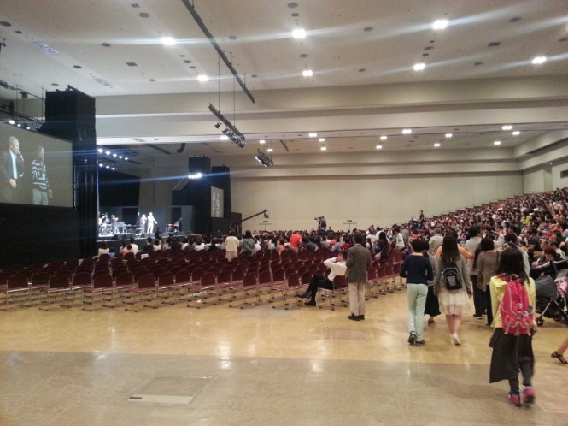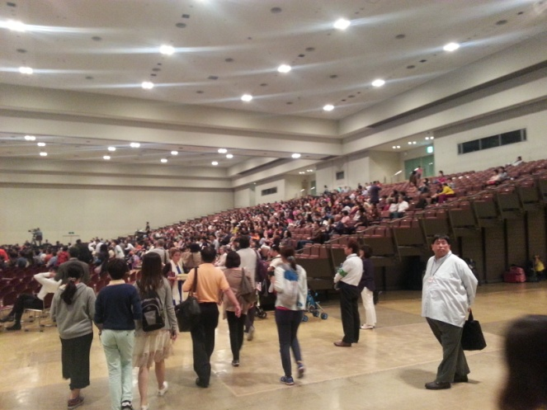
Convention centre. [Holds about 4000]

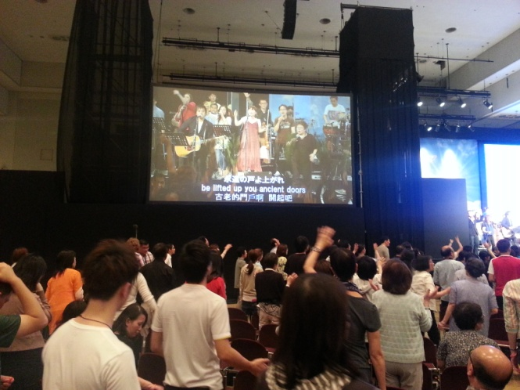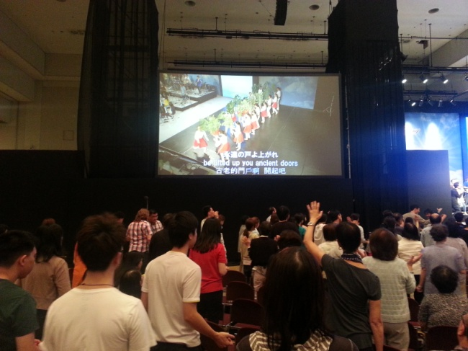
Worshipping the Lord together

#3
… It would be almost impossible to share everything that has been happening here at the gathering! There has been so much happening in every session, I hope some of you are able to follow along on the web stream.
I think it was yesterday morning they had all the little children go up on stage with the dancers [our Canadian team from Alliance’ et Vie Montreal] They must have been up there for ½ an hour, it was so precious and powerful. At one point a little girl maybe 5 or 6 was up there and blew the shofar…. it was unbelievable how well she did! … ‘a little child shall lead them!’ We know the Holy Spirit is leading us so weather it is a little child or anyone else it is a joy to follow.
It’s amazing how many whole families with little children are there. Last night a [Danish family I think] a family from Israel were asked to come and share … they had been at the Gathering in Israel and the wife said after the gathering there she felt some strong longing in her heart and thought she was missing her family in Denmark so her husband suggested they go visit but as soon as he said that she knew that was not what she was feeling … she realized that she need to reconnect with the global family by going to the Japan Gathering. She asked her husband if they could go and he said yes so they just came with their whole family to be together!!
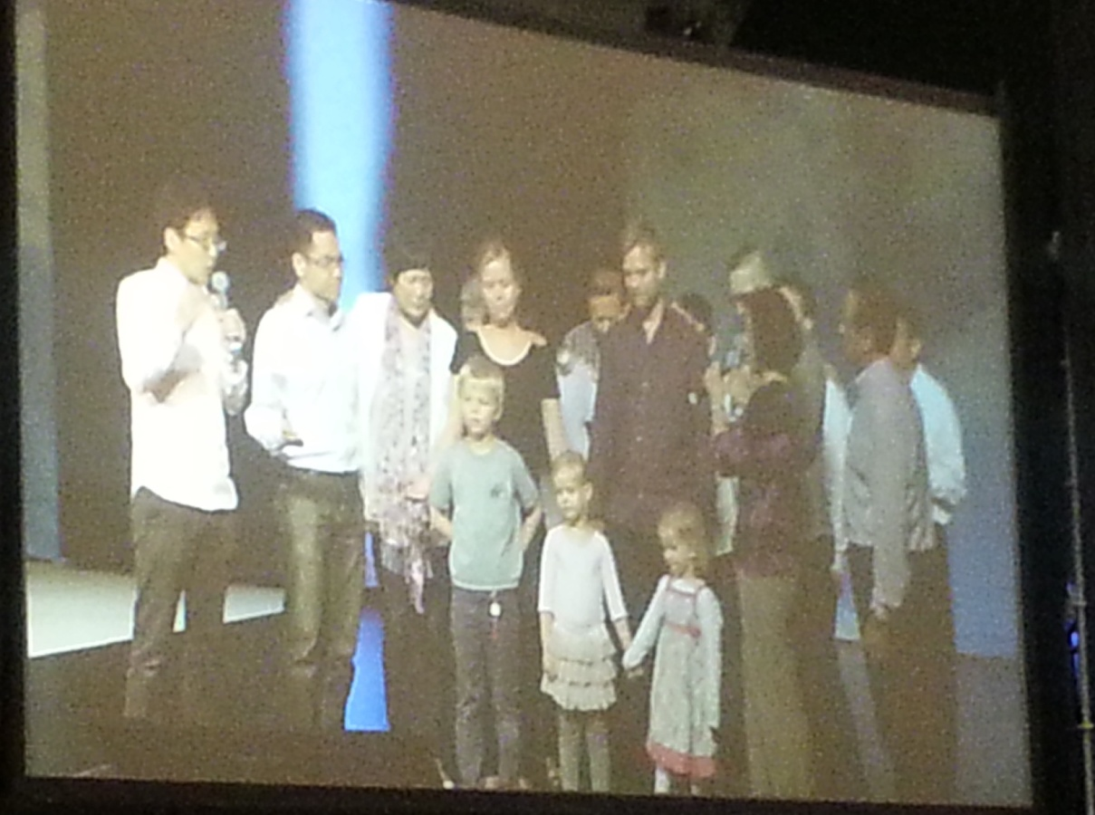
--------------------------------

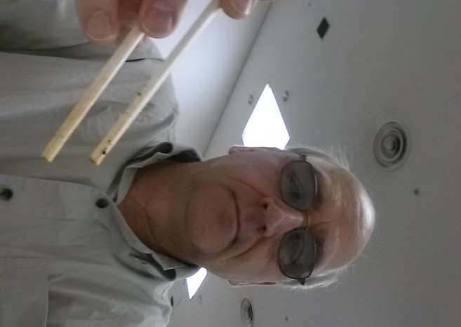I’m finally sort of got chopsticks figured out!

The picture below was made by Joanne Lepp a friend of ours from Regina … it is not a painting or a drawing… it is made out of fabric! She brought this from Canada to give to Japan..
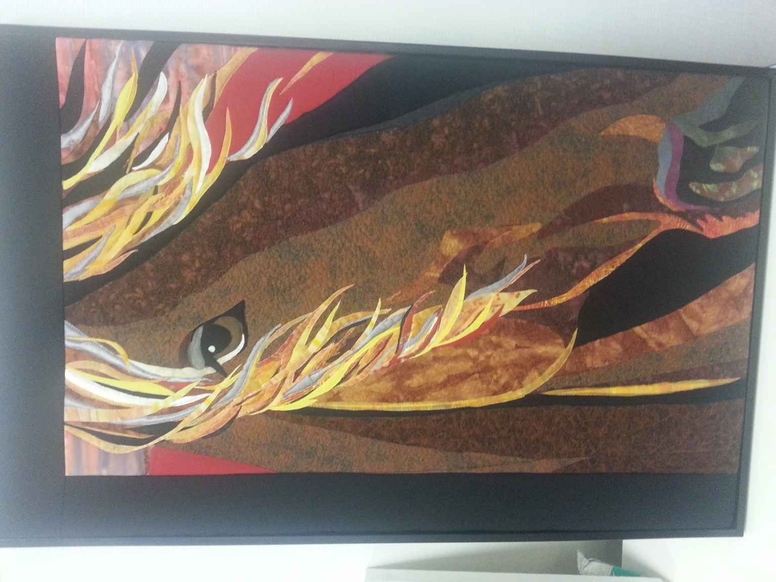

Here is what the Lord showed Joanne about the picture:
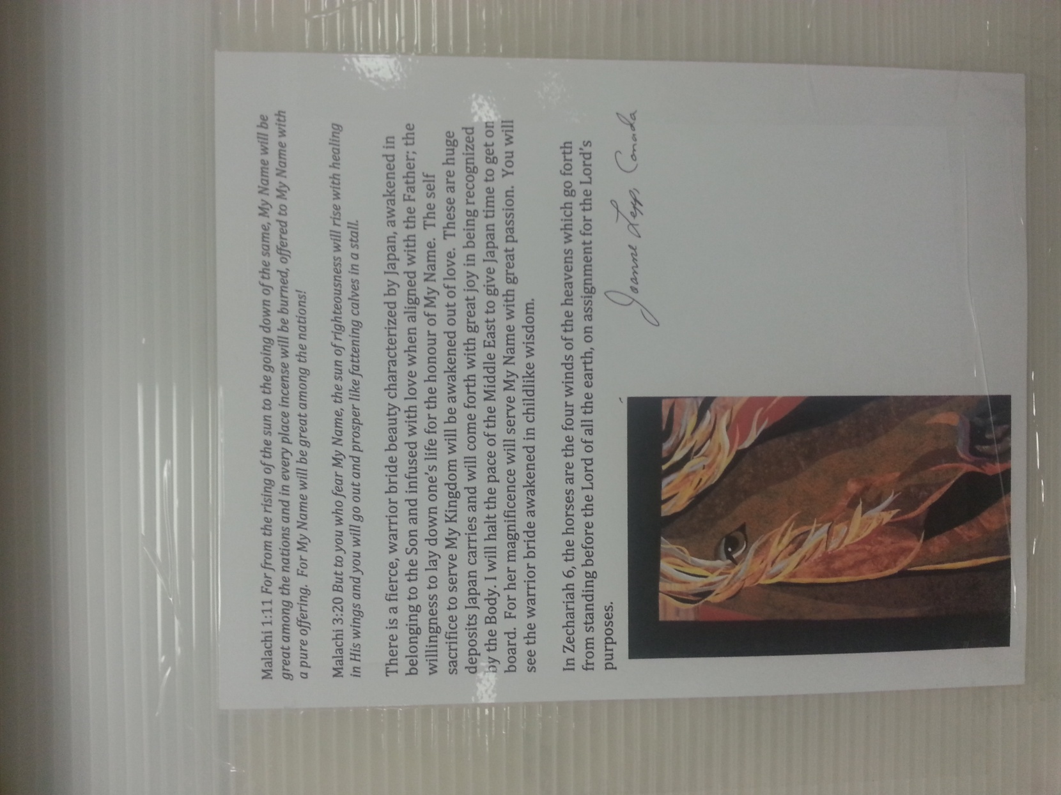

--------------------------------------------------------------------
#4
On Wednesday morning a group of native people from Taiwan showed us their traditional worship and dance to the Lord. This group has been praying together every morning at 4 am for 60 years!
They where releasing ancient sounds…
Taiwan presents worship and dance ….. Amazing, at first it sounds like a hymn. I feel like I'm listening to Ziemer family acappella. I could hear our John Zie's voice clearly. (thanks for coming with!!)
…Shift…. They start to chant ancient sounds released into the earth. The enemy fears the ancient sounds
( as they were drumming and declaring I felt the power of the Holy Spirit awakening our spirits. I thought wow! What will happen with every tribe and tongue and nation!!) …~ beth

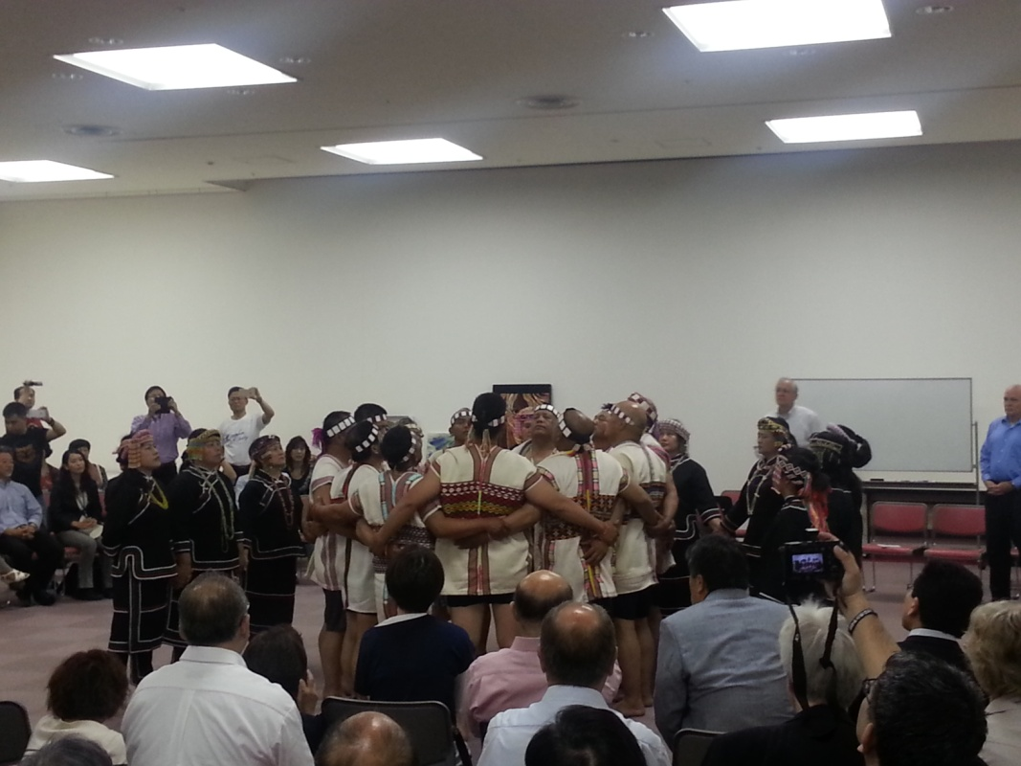

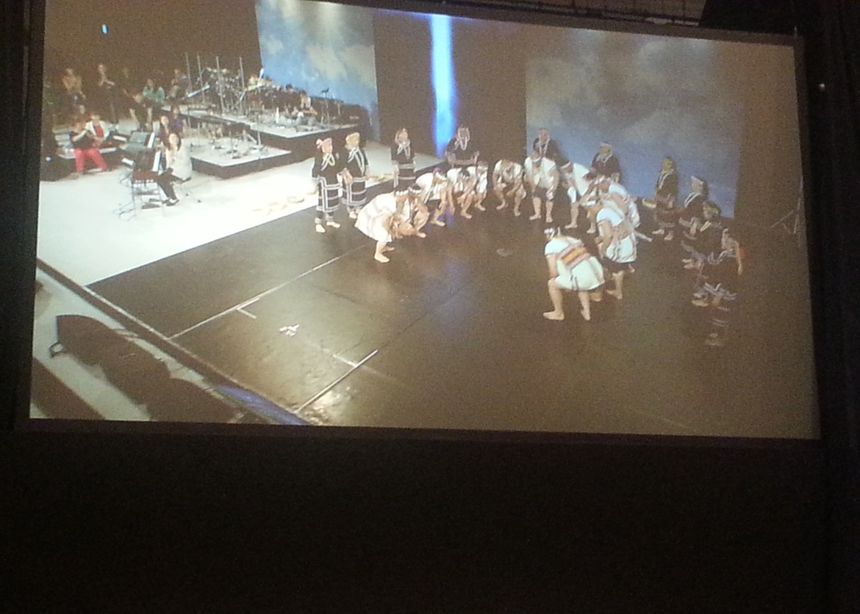

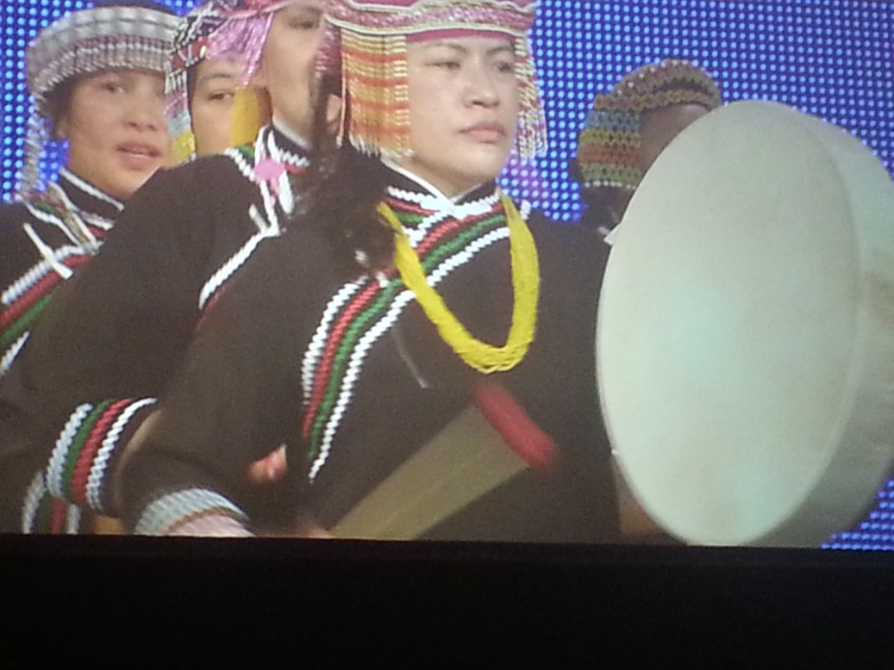
----------------------------------------------------------
Through the whole Gathering the worship was very powerful and intense …. Everyone was fully engaged right from the very young children to the very old grandparents. It was like everyone understood that we were not only having a wonderful time together but that the Lord was shifting many things in the spirit realm through our obedience to worship Him. He is shifting and aligning nations, bringing the global family of God into unity for the sake of His Kingdom.
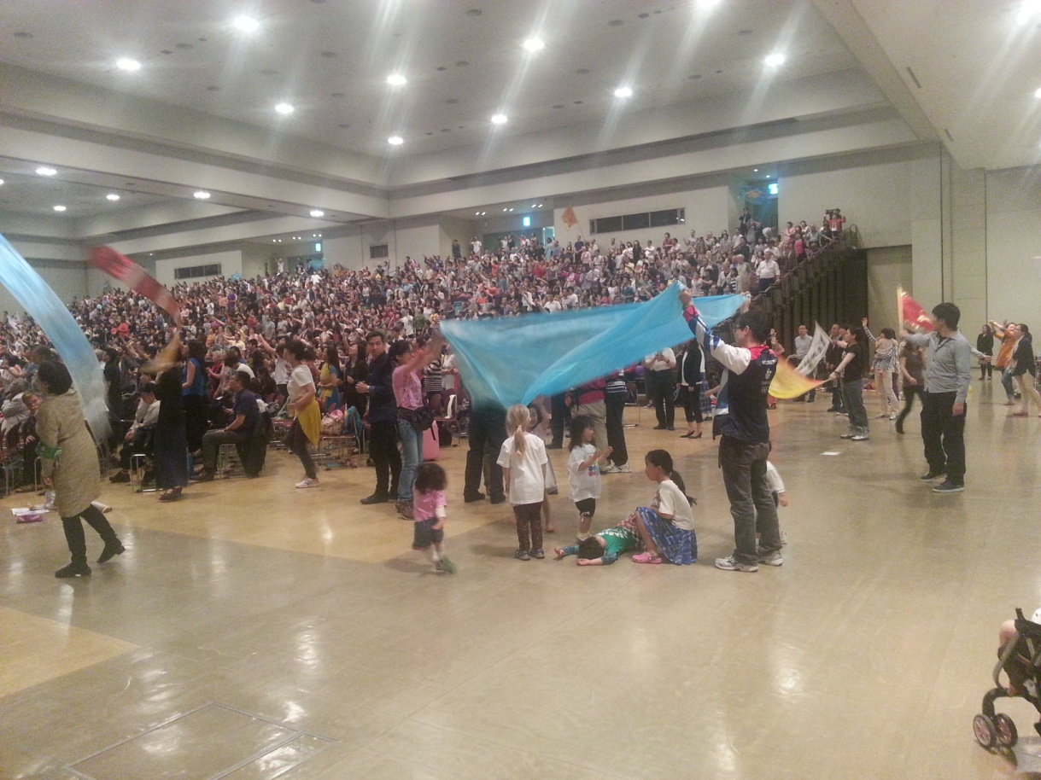
====================================================

During WW2 there were some countries that made an alliance in order to advance their territories and their power. Two of the main nations that did this were Japan and Germany, both knowing that each had ‘hegemony’: Leadership or dominance in their respective geographical areas; Asia and Europe.
During the last short while … a year or two … representatives of the church in Japan and Germany have been deeply knit to one another and the Lord has revealed to them that His intention from the beginning was that there would be a ‘Holy Alliance’ between Japan and Germany. They are both ‘father’ nations and have a critically important role to play globally in the Kingdom/ end time purposes of God. The enemy has stolen their God intended purpose but now the church through the Holy Spirit is rising up to take back what the enemy has stolen. …… During the Gathering here in Kobe there was a covenant; a ‘holy alliance’ made between Japan and Germany in which they committed themselves to stand together, to love one another and to serve the body of Christ worldwide for the sake of Jesus Christ. … This was a very deep and powerful act that we witnessed and entered into together.

Here are a few pics from that session during the Kobe Gathering:

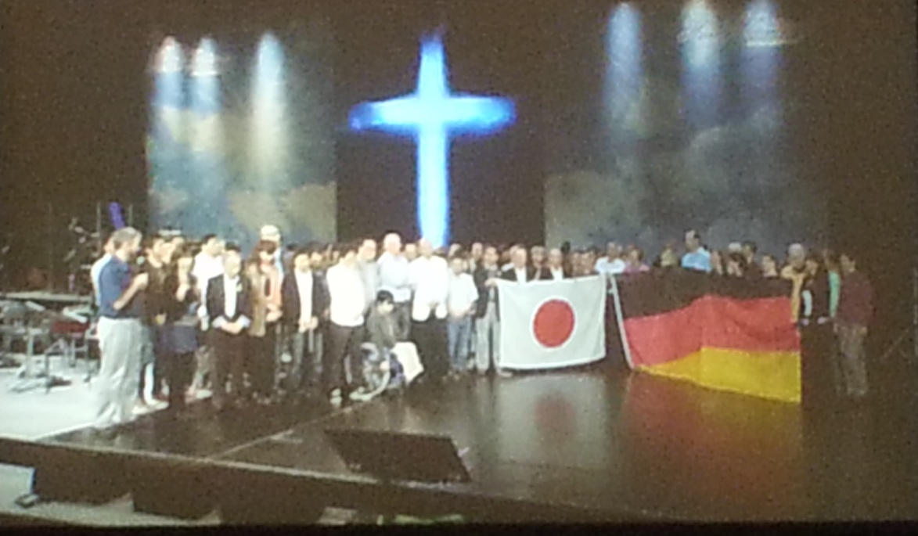

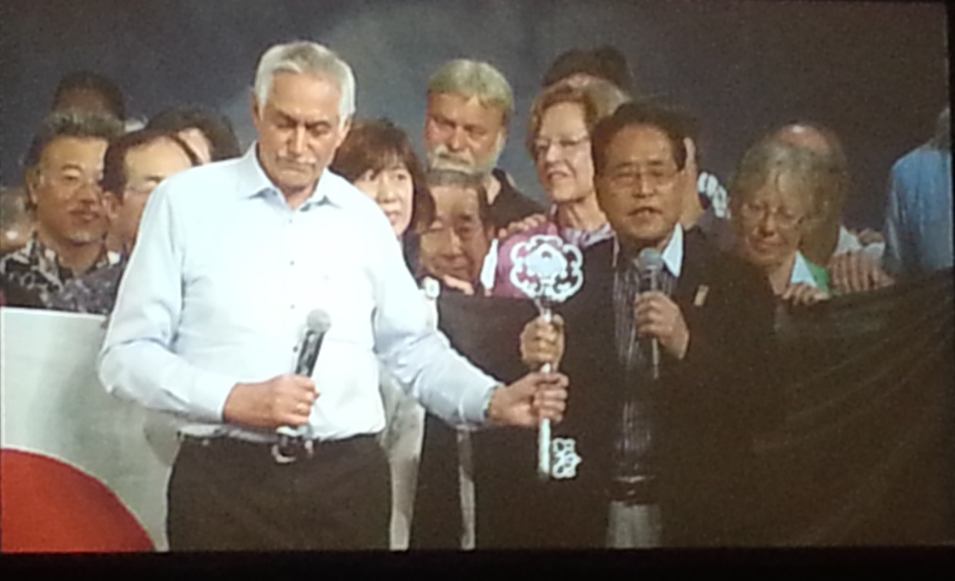
=================================================

The very last thing we did was pray for the peace of Jerusalem…. Right now is the time of the fullness of the Gentiles.
Rom.11:25 - For I do not want you to be unaware, brothers, as to this mystery— in order that you not be wise among yourselves— that a hardness in part has happened to Israel until the fullness of the Gentiles comes in.
… This ‘fullness’ is referring to the full number and fullness in regards to maturity … then!.... ²⁶ and so all Israel shall be saved: even as it is written, There shall come out of Zion the Deliverer; He shall turn away ungodliness from Jacob:
It is time for the fullness of the Gentiles and for the veil to be removed from Israel so that they can see that indeed Jesus is the Messiah!
- This is a picture of a Jewish, Messianic believer he was covering his face with a prayer shawl then lifting it off as a prophetic declaration that the veil is being removed!
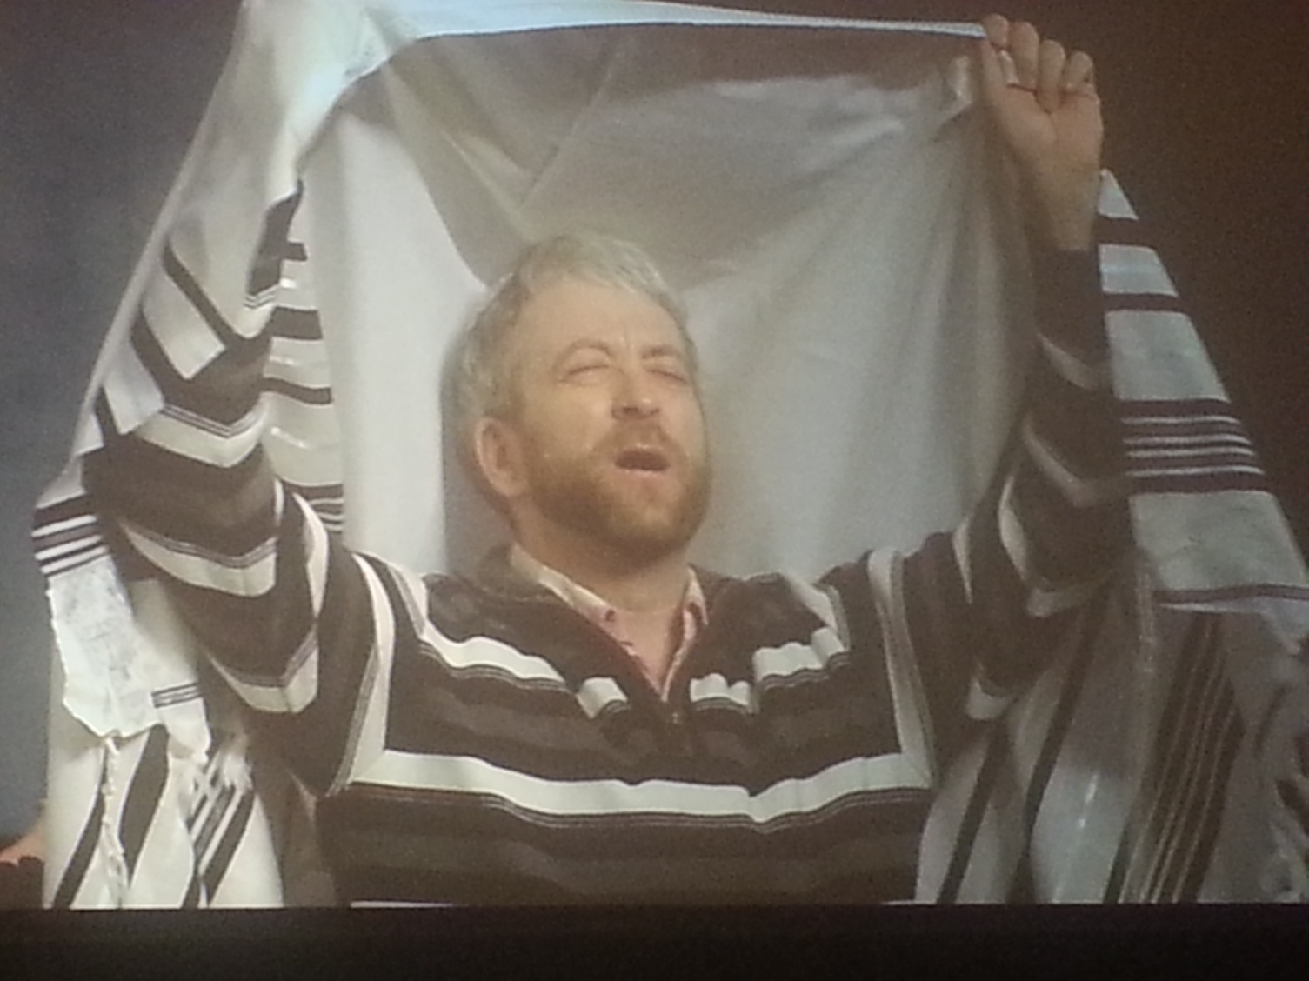
Amen Lord! Your Kingdom come Your will be done on earth as it is in heaven!!
---------------------------------

There are many, many gatherings happening this year globally there is an intense desire by many in the nations to seek the Lord and come into His full purposes for the bride of Christ.
There are several more Gatherings planned for this year [2015]:
- Hong Kong : July 7-10
- Canada: August 19-22, Edmonton
- Singapore: Sept. 14-16
- Germany [Global Gathering] October 25-28, Munich

…. All our love, pbzie, May 3-6, 2015

