Global Gathering Report- Munich, Germany
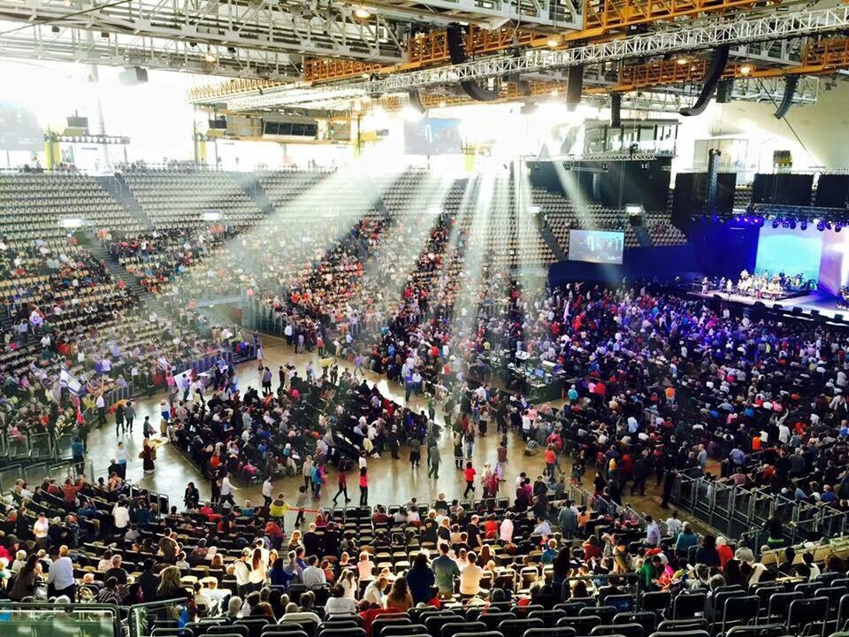

“Stop dwelling on past events and brooding over times gone by; I am doing something new; it’s springing up—can’t you see it? I am making a road in the desert, rivers in the wasteland” (Isaiah 43:18-19).

Praise Opens the Way…
Anticipation lingered in the air like a physical presence in the hours before the start of the Munich Global Gathering. Olympic Park in Munich, Germany is expansive and impressive, but the sight of thousands of believers assembled from more than 45 nations for four days of worship, prayer and declaration was awe-inspiring. The excitement everyone felt as we gathered together as a global family was tangible, and our eagerness to exalt the God of all Nations was uncontainable. By the time the last session ended late Wednesday afternoon, those who attended in Munich had been joined by people watching the live stream broadcast: over 140,000 individual hits from more than 100 nations.
The first strains of music began, and young and old alike raced to the front of the arena, so they might join as an integral part of the worship through song and dance. Even though many of the attendees had just finished traveling—some for as long as 20 hours—they were immediately energized by the Spirit of unity and the sounds of worship that resounded throughout the arena. Intimate, long-time friends danced together; others made new friends, discovering that their hearts were bonded as if they had known each other for years.
It is never a surprise when worship takes over the entire session. The worship team consisted of musicians and singers from different nations, many of whom had not played together before, but they genuinely carried and beautifully expressed a heart of unity from the very beginning. The pleasure of the Father filled the arena, and one could feel Him reveling in joy as His love cascaded over His assembled children with penetrating joy and intimacy. From the beginning, we were keenly aware of the reality that He is a “good, good Father”, as that song lingered on the lips of everyone through the night.
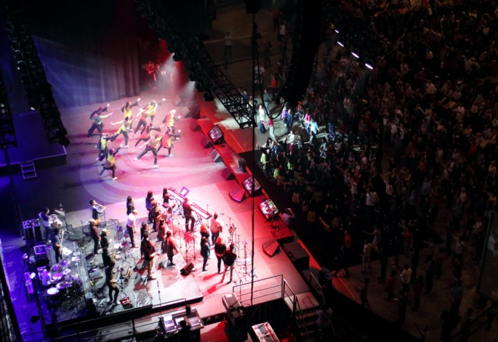

There were amazing blessings released as the global family of God assembled in Munich with no prearranged agenda other than to seek the face of our Lord in humility and worship, that we corporately might discover what He would say and do. Our Father graciously met with us, pouring out His mercy and His presence with wisdom and power far beyond anything we could ask or think. As we became acutely aware of the “new thing” that the Lord is doing in these days, two themes appeared to dominate our times together: the Father’s intense love for us, His family; and the importance of our expression of that love one to another through honouring each other in humility.
Following are some highlights from those incredible four days:

The German Family…
For many of us, this was our first time in Germany, and having the opportunity to experience the warmth and joy of our German family was like receiving a long-awaited gift. It seemed as though Heaven and Earth had anticipated this moment since the nation was birthed. The German family looked like a people who were dreaming. The nations had come to their homeland to honour all the redemptive gifts that Germany had given to the Church, and to release them from their shame caused by historic events that had brought dishonor upon them. The Church in Germany has longed to carry the Father’s heart to the nations, and the nations have longed to receive their heart. Seventy years have passed since the end of WWII, and God gathered believers from around the world to release blessing, so that He might release healing to His people in Germany, freeing them from false identity and calling them into their destiny as those who provide safety and refuge.
During one session, a German girl stood on stage and shared how she had not been able to step into her true identity in Christ because of the fear and shame she carried from being German. At that point, we witnessed some of the Jewish leaders declare over her, and over the youth of Germany, “We forgive you and are willing to forget.” Chinese and Japanese leaders also released blessing and expressed their willingness to lay down their lives for the sake of their German brethren. It was a profoundly healing experience of reconciliation, as we realized in a new way how deeply we all need each other.
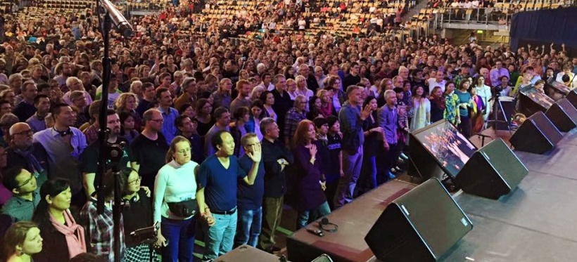

Worship Ushers in Breakthrough between Isaac and Ishmael
Each session began with extended times of worship through song and dance as the Lord was lifted up. These times of bringing Jesus the honor He is due ushered in times of breakthrough for individual nations and people groups, as well as for the corporate body.
One session brought about an event that seemed to spring up by surprise. Jewish and Arab believers had gathered on stage with the intention of entering into a covenant of family, so that they might honour the prayers and blessing of Abraham. Asher Intrater from Israel stood and spoke on behalf of the assembled Jewish leaders, saying to their Arab brothers and sisters gathered before them, “We tell you that we love you, that we honour you and there is no people group in the world we feel closer to, and that Abraham blessed you before we were even born…and all the great promises of God for the Jewish people will not happen until God’s blessing on the Arab people comes first…we are the first family of Abraham together.” He then declared the Arab people “beloved,” possessing destiny in Christ and linked by covenant with the Jewish people as family by the blood of Jesus.
As the words were spoken we could feel the “weight” of God’s presence flood the arena, and the air was filled with the sounds of exultation, shouts of joyful agreement, and the trumpeting of shofars. David Demian and other Arab leaders knelt and prayed, noting that from that place where blood was shed in 1972, they were now asking forgiveness for hatred and animosity between brothers, and prayed for the peace of Jerusalem from the depths of their hearts. Everyone present realized we witnessed an historic event, with blessings that would continue to take effect into the future.
Due to the representation of many nations present, there was power released through the critical mass that established something on Earth as it has been declared in Heaven. Immediately following the pronouncement of covenant with each other, our Jewish and Arab family joined together to bless the international body, and prayed that we would be one family, united with our Father in heaven and joined as the extended family of our father Abraham. This was a powerful moment of historic fulfillment of the prophecies and promises of Scripture for the people of God to be a family together.
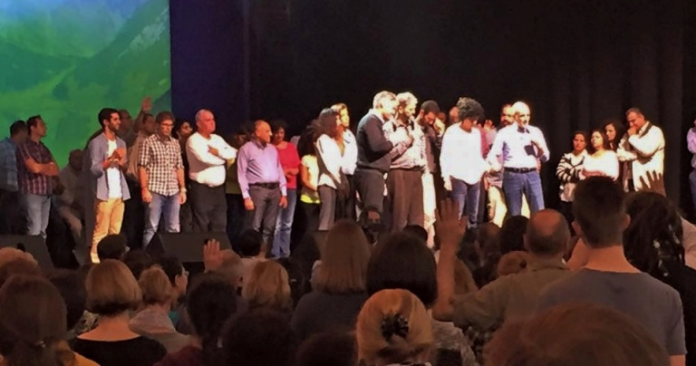

Fathers and Sons, Mothers and Daughters Walking Together
The younger generation (children to age 30) was well represented at the gathering. Many young people sacrificed time away from school, and spent what resource they possessed to join in worship with their global family. We heard stories of young people giving up their jobs and their limited funds to obey the Lord and come to Germany. This was so pleasing to the heart of the Father that it opened up the way to see great freedom come to these precious ones.
They stood before the nations gathered and shared the desire deep in their hearts to walk with the fathers and mothers as one family. They spoke great honour over their natural and spiritual parents. They repented of all dishonour and rebellion. They even covered any shame that the fathers and mothers had experienced from mistakes. Honour was the key that they used to restore and rejoin the family.
And he shall turn the heart of the fathers to the children, and the heart of the children to their fathers, lest I come and smite the earth with a curse. Malachi 4:6
Over and over, young people opened their hearts and shared that they felt safe and were being released into freedom to be able to walk with older generations. They expressed their realization that honouring each other brings the blessings of unity, enabling us to merge with each other to have one heart with the Lord. Honour breaks the orphan spirit that seeks to continually divide and isolate us, making it increasingly difficult to love one another and walk united in freedom and purpose. People from every generation and every nation are wounded by the pain caused by the darkness of an orphan spirit, but the Father of Lights is pouring out His love to bring wholeness, healing and unity.
One of the German fathers then stood before the younger generation and shared how the honour and humility that they expressed enabled him to lay down the shame from his generation, and that he now knew he was welcome to walk with them as a father does with his children.
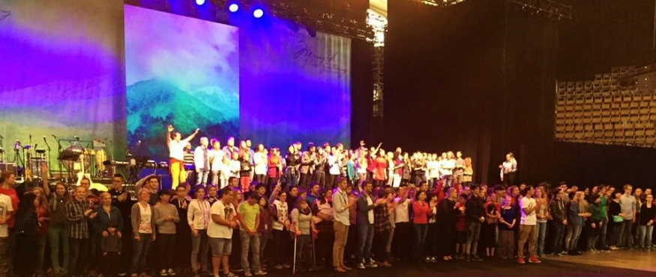

Japan and Korea Honored among the Global Family
Remnants of believers from Japan, who have been faithfully facilitating national gatherings in their country, were among us and the Lord desired to also bring them honour within the family. After sharing their hearts and the journey that they have been walking in Japan, a receiving line formed consisting of believers from Germany and representations of believers from the other nations, all joined to bless them and express the Father’s heart. It was such a tender moment that showered our Japanese brothers and sisters in love and joy.
The next day, we were privileged to hear the hearts of our Korean family. Believers there have also struggled for many years, sharing the pain of disconnect from each other and the worldwide body of Christ that many of them feel. They thanked the German church for their role in blessing Korea in the past, and pledged their love for the rest of us as well. The first national Korean gathering will take place January 19-22, 2016. They invited the nations to stand with them and support them as they humble themselves before the hand of God and before the nations to see their divided land unified and God’s original design for their people restored.
http://koreagathering.org/en/home-en/
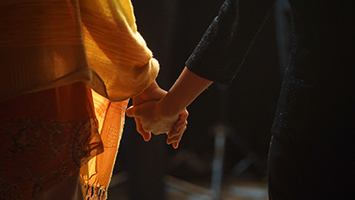

Germany, Austria and Switzerland are free indeed!
Another deeply emotional moment occurred when God made a place for the nations to declare Germany free of their historic shame from the past 70 years, and proclaim a new day for Germany. The “Fatherland” was restored and their true identity released. Worship exploded with great joy, dance and freedom as the German speaking people joyously abandoned themselves and embraced their “new day”. Once again we experienced the promise of Isaiah 43:19 released as we saw freedom “spring forth”. Watching tears of joy stream down the faces of those from Germany, Austria and Switzerland was overwhelmingly beautiful.
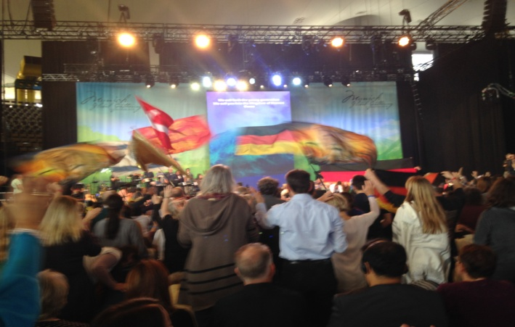

Hearts Overflowing
The Global Gathering culminated with honouring all the different ones who offered their talents and gifts.
There were amazing artists, who poured out their worship and prayers through different creative mediums such as paint, fabric, sculpture and photography. There was the worship team that consisted of many different nations who worked in unity and oneness with many voices, instruments and languages. There was the dance team which brought choreography, costumes, prophetic props and the heart to release all that the Spirit showed them to do. There was a large prayer team called the Unity Team that spent months praying prior to the Gathering. They also spent their session breaks praying together, releasing the cry of the Lord and protecting all that the Lord desired to do. There was the administration team that brought their gifts so that everything run would smoothly and everyone attending would feel loved and cared for. Most of the administration team served late into the night and woke up early to be sure that every detail was taken care of.
What a beautiful family, from many nations, tribes and tongues…all working together to see the longing of the Lord fulfilled. Their hearts overflowed with love for their Beloved and for one another and it was expressed in everything that occurred. The language of love is universal—the one language that did not need translation. It was heard by all, experienced by all, released by all and embraced by all.
Now is the time. Deep hunger grows and cries out within us all for more of Him, more connection with each other, more of the Body being knit together in joyous love and organic oneness. We continue to gather in His presence, and our shouts of praise, our cries, our petitions, our declarations rise again and again as incense, a fragrant perfume of worship to our King, filling the bowls of heaven in preparation for a great outpouring. Abba’s desire for His family to be one in Him will be fulfilled. His desire is being fulfilled!
God truly knits us together to restore relationships between nations, people groups, cultures, languages, and generations. He truly accomplishes what no man can accomplish.
Whether you were able to physically attend the Global Gathering or not, know this: the reward is the same for all! We all have the same Father and His reward is the same no matter where you are or what you are called to do. All honour goes to the One who is worthy of all our praise. He truly is a good, good Father.

https://www.youtube.com/watch?v=l1lYk2oYvC8&feature=youtu.be
To watch the archived Live Stream sessions go to:
http://www.watchmen.org/global/munich/en/

