Emmetten, Switzerland … May 12- 16, 2015 …. Pbzie

We arrived at 8 am Monday morning and got to the hotel by 11 am and the meetings didn’t start until 6 pm so we had some free time… a bunch of us went exploring :o)
Oh so beautiful. Went up in the gondola, (super ridiculously high), watched people paraglide off the mountain. Amazing. Fancy dinner - duck in vegetables as well as other stuff. Tired!! Hitting the wall. Just about to start the meeting. Translating into German Chinese Japanese, Spanish with headsets and the rest can speak English as well. Not sure how many nations are represented here. There will be about 120 of us, most here, some arriving tonight
Love you much ~Beth.
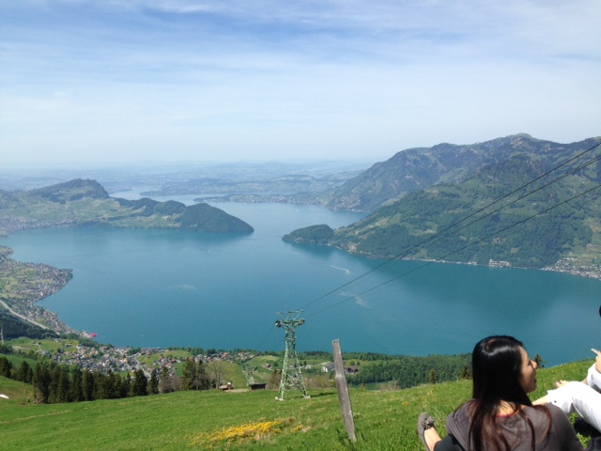
View from the top

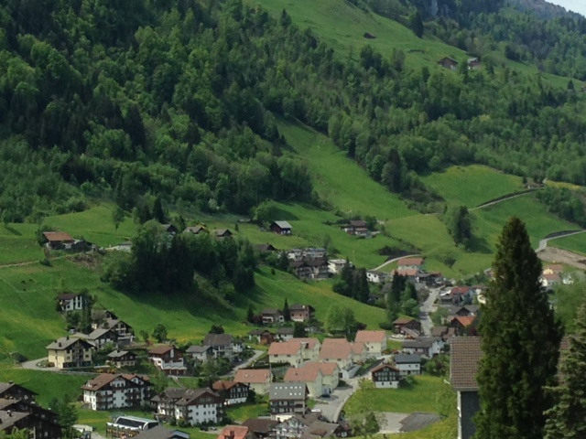
Houses in the village of Emmetten

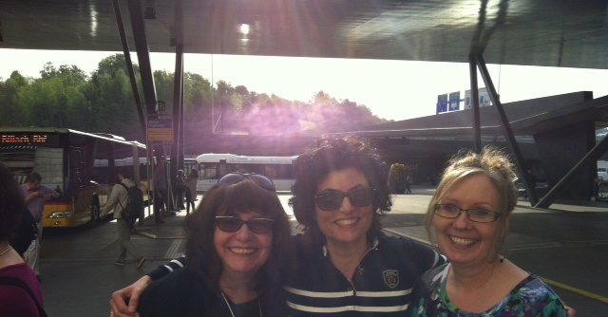
Newfoundland / Nazareth / BC
... Our first meeting was a amazing: I’m guessing about 15 nations gathered, many old friends and many new. The presence of the Lord is very rich and the ‘family feel’ is very strong … we have come here because it is a ‘leadership pre- gathering for the global gathering that is going to be in Munich Germany this Coming October 25-28. …. Often times in this situation we would think that we really need to do everything we can to ‘figure out’ what the Lord wants but we realize that the reality is, is that He is here already and He wants to reveal His heart to us so our ‘job’ here is to deepen family love and ties and to continue to prepare a resting place for the Lord and He will reveal His desires to us!
I am not sure how much time I will have to post updates but I do want to thank you for your love and for your prayers … it is truly good to walk together as a family.
…. Love to all, peter and beth.

==================
#2
It is like a fore taste…. Every tribe and tongue and nation worshipping the Lord together!
